Wind Turbine Design Project E10 Introduction to Engineering
Project Guidelines
Humans have harvested energy from the wind for centuries. Sails for ships and windmills for grinding grain or pumping water are a few examples. There is renewed interest now in harvesting energy from the wind, because it offers a pollution-free means of generating electricity on a significant scale. The system that accomplishes the conversion of wind energy to electricity is called a wind turbine.
This semester you will design and construct a wind turbine and explore some of the engineering principles involved. The project consists of four major activities:
- Designing and fabricating the turbine rotor blades
- Designing and fabricating the support tower
- Determining the power output of your turbine
- Measuring the stiffness of your support tower
Grading of the project will be carried out using the following criteria:
Turbine Performance (80 points)
- Power generated (30 points) Your wind turbine will be tested at a wind speed of 25 mph and at various electrical loads. The higher the power output, the better.
- Stiffness of support tower (20 points) Your support tower will be loaded transversely (simulating wind loading), and its deflection will be measured 17 inches above the base of the tower. The less deflection (stiffer), the better.
- Weight of structure (16 points) Your structure will be weighed. The lighter, the better.
- Meets specifications (10 points) Your structure is within the height limits specified, is oriented on the platform as specified etc.
- Creativity (4 points) This aspect will address innovation and creativity used in your design.
Report and Presentation (70 points)
- Report on the design and its performance You need to document your design and performance results in a written report. Your report will be assessed on the quality and completeness of your documentation. (See the guidelines for writing the report below and the rubric that describes how your report will be evaluated).
- Presentation on the design and its performance You will make a 5 to 10 minute presentation describing your design and the results of its performance. (See the guidelines for the presentation below).
Bonus Points (varies by instructor)
Bonus points may be given for the wind turbine that generates the most power, is the lightest, has the highest stiffness, or has the highest stiffness/weight ratio.
Details on Activities for the Wind Turbine Project
Turbine Project Lab 1 – Learning How to Design with Solid Modeling Software
In this laboratory period, you will get some training in three dimensional computer-aided design using SolidWorks, a leading-edge solid modeling software. You will begin to apply what you’ve learned to design the blades for your wind turbine.
[Note: the SolidWorks software is available for students to download and use for free. Follow the instructions for how to download SolidWorks that are given on the web site for E10.]
Turbine Project Lab 2 - Designing and Fabricating the Turbine Rotor Blades
Building on what you learned from the previous lab assignment, you will design and fabricate your turbine rotor. Before you come to lab, you should do some research on wind turbine blades to decide on the best cross section, how the blade should be shaped, how many blades, etc.
Turbine Project Lab 3 - Designing and Fabricating the Wind Turbine Support Tower
The goal of this assignment is to design and fabricate a support tower for your wind turbine. You will be given a base and upper support plate between which you need to design a supporting structure. The dimensions and orientation of the support plates and their required spacing is shown in Figure 1. Important note: find out from your laboratory instructor what restrictions will be imposed on the materials that may be used for the support structure. You may attach your structure to both support plates as needed, but they may not be otherwise modified (i.e., hollowed out, etc.)
Turbine Project Lab 4 - Performance Testing of the Wind Turbine and Tower
In this laboratory period, you will weigh your structure, measure its height, and measure the power output from your turbine and its efficiency, and stiffness of your support tower.
Turbine Project Lab 5 - Presentation
Your team will make a 5 to 10 minute presentation describing the design and results of performance testing. (See the Guidelines for the Project Presentation below). A report documenting your design and its performance will be due in lab the following week. (See the Guidelines for the Project Report below and the rubric that describes how your report will be evaluated).
Specifications
Construct and attach the supporting structure for the wind turbine between the upper and lower support plates as shown. The support plates are approximately 0.75 in. thick pine or Douglas fir wood. The 17 in. overall height must be maintained to within ±1/16 in.
The support structure must not extend beyond the envelope defined by the base dimension of 11.75 in. x 11.75 in. over the 17 in. in height.
The upper support plate sides must be nominally parallel to the lower support plate sides as depicted in the sketch. The support structure is to be attached to the upper and lower support plates by suitable means; however, the support plates may not be otherwise modified.
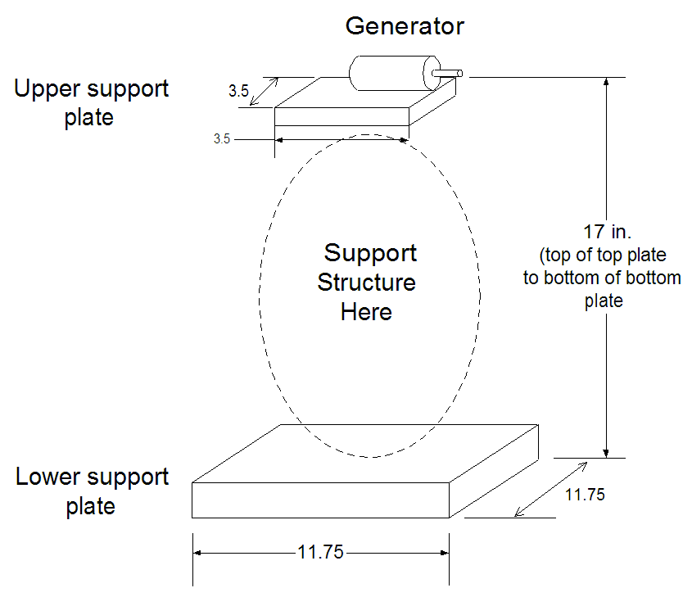
Wind Direction
Figure 1. Schematic of Wind Turbine Tower Supports and Dimensions.
See next page for guidelines on the presentation and writing the project report
Project Presentation Guidelines
- One presentation for your group. All group members should participate in the presentation.
- A title slide that lists: the title of the project (descriptive and specific), the entity for which the presentation is being given, i.e., San José State University, Charles W. Davidson College of Engineering, E10 Introduction to Engineering, the names of the team members, the date of presentation, lab section number, and professor.
- Overview of project and its goals (1 or 2 slides)
- Several slides that clearly show and explain (you may need more than one slide for a particular topic):
      - The design of your support tower (include your rationale for why you designed it as you did)
      - The design of your turbine blade (include your rationale for why you designed it as you did)
      - The performance of your wind turbine and support tower. Compare the power of your wind turbine to the ideal maximum value and calculate the efficiency of your turbine. Describe how performance was measured. Be sure to include tables and graphs of relevant data and trends:
        - Power generated
        - Height, weight, and stiffness
      - Conclusions and Recommendations for Further Work (also include what you might have done differently knowing what you know now)
Project Report Guidelines (One report per group)
- Title page lists at minimum: the title of the project (descriptive and specific), the entity for which the report was written, i.e., San José State University, Charles W. Davidson College of Engineering, E10 Introduction to Engineering, names of the team members, E10 section number and team number, name of section instructor, and the date of submission.
- Project Summary section succinctly and specifically states: The objective(s) of the project, the outcome/results (as per project guideline requirements), summary of all the “performance data.” This section should consist of three to five paragraphs, and be about one page long. A figure (or a photograph) that provides a good visual summary of your project is appropriate for this section, but no more than one. Remember, each figure should be numbered and have a caption. Talk about and refer to figures in the text.
Think of the Project Summary section as the ‘Reader’s Digest’ version of your report. The Project Summary gives the key aspects of the project in a concise form. It must include a summary of the performance data (weight, height, maximum power, stiffness, costs etc.) and should include the outcome of your project (Did it successfully achieve the design objectives? Were there significant failures?) The rest of the report will elaborate on what you did, how you did it, and what happened.
- Table of Contents: Number report pages starting with page 1 as the Introduction page. Title page has no number and other pages before Introduction can be numbered i, ii, iii, etc. The Table of Contents should include all the sections / subsections headings with the starting page number for each. It comes after the Project Summary.
a. Refer to any of your texts for an example of this section.
- Introduction: This section describes relevant background information. (1/2 to 2 pages). It describes what the project was about, first in general, but then specifically, presenting the specific objectives that your design addresses. To write this section, refer to the Project Description regarding goals and specifications found on pages 1-2 of this handout. This section should be at least one page long. Make sure that you include sufficient sketches, drawings, and/or photographs and verbiage to clearly explain to someone unfamiliar with this project what it is all about. You may use sketches from the Project Guidelines, but cite your source.
- Theory: Describe briefly the theory(ies) that apply to your project, including any applicable formulas.
- Design – Build - Test: Give a brief description of your turbine blade and structure design including:
    - Relevant sketches, drawings, pictures.
    - Type, shape and dimensions (and possibly cost if known) of the materials used
    - Name/describe the major tools used during the “Build” cycle
    - Briefly describe the type of tests performed on the project, the purpose of each test and its outcome.
    - Name/describe the major tools/measuring equipment used during testing
    - Include data plots for the following parameters and briefly discuss the performance.
      - Turbine Stiffness
      - Voltage vs. Current
      - Power vs. Current
- Compare the actual power generated versus the theoretical power, and calculate the efficiency.
Consider putting performance results in tables. Create a graph of your load and deflection data, and use Excel curve fitting techniques to determine the stiffness. You will have achieved success in writing this section if a peer in the class could take what you have written, and referring to it alone, be able to reproduce your device.
- Conclusions summarize the work done, what was learned, and the outcomes of the project, such as how well it worked or didn't work. How did the efficiency of your turbine compare with the efficiency of typical turbines in use today?
- Recommendations for Future Work: Include some recommendations of what you would do if you had more time to improve the design or what you might have done differently knowing what you know now. Here you want to make sure to give specific recommendations for improvements or further work. For example, a poorly written recommendation might say something like, “… we would make the turbine blade go faster.” A better one might read, “… we would use four blades instead of three to develop more power, since power is related to blade area.”
- Reference section. Any references listed should be cited in your report. Examples of how to cite references can be found in:
http://www.lib.nus.edu.sg/lion/s/citeapa.html
http://www.lib.nus.edu.sg/lion/s/apastyle.ppt http://www.engr.sjsu.edu/bjfurman/courses/ME120/me120pdf/ME120labreportguide.pdf
Note that the reference list must be alphabetized. Remember that any material you include in your report that you did not create by yourself or that is common knowledge, must be cited as reference, or else you are committing the ethical violation of plagiarism (which must be reported to the Office of Student Conduct and Ethical Development). You must cite any of the materials from the E10 web site.
- Appendices contain any other information that, in your judgment, might be a big help to someone trying to do a similar project (data sheets, catalog pages, etc.).
Required appendix elements
- Appendix A - Original data sheet used in the laboratory
  - Appendix B evaluates teamwork by answering the following questions:
    - Who worked on each aspect of the project
    - Who contributed to each section of the report
    - Describe one challenge the team faced, how the team resolved it, and a lesson the team learned from that experience.
    - Use the table below to rank (on a scale of 5 to 1) your team performance in the following six areas
(5= we all did this all of the time to 1= did not do this at all )

Teamwork Skill | Performance Level
1) open and honest communication among members
2) each individual carried his/her own weight
3) collaboration in decision making
4) team set goals and milestones
5) people listened to each other
6) leadership was shared among the members

Helpful Hints
- Have someone other than the author, proofread the report
- All tables, charts, pictures, drawings etc. must have a number and a title/caption.
- Do not split tables, charts etc. across pages
- Use short paragraphs
- Number all the pages of the report
- Use the same font throughout the report (except headings, titles etc.)
- Use past tense

