Homework #1: Introduction to Mechatronics
Dr. Furman’s section: Due Thursday, 2/4/16 softcopy in Canvas
Dr. Rahimi’s section: Due Monday, 2/8/16 hardcopy in lecture
Use the Homework Template file for your homework responses. Don’t forget to fill out the cover sheet completely. Include a summary of what the assignment was about, and what you learned in doing it. Where written responses are requested, please type them. Make sure that you show how you arrive at any answers involving numerical calculations. Answers that do not show intermediate steps will likely not earn many, if any, points. Remember that you must turn in a softcopy of your work in Canvas in order to receive any credit for this assignment. Hand written solutions can be included by scanning them or by including a clear picture of them in the softcopy submission. [Such submissions must include evidence that the work was original to you or they will be considered to be plagiarized, and you will receive no credit for the assignment.] Copy and paste additional table cells as needed.
- (10 pts) Visit: http://www.ted.com/talks/massimo_banzi_how_arduino_is_open_sourcing_imagination.html Describe the ‘revolution’ Massimo mentioned that Arduino is part of. How is Arduino contributing to it?
- Visit the Mechanical Engineering Magazine feature article from May, 1997, “Getting a Hold on Mechatronics”: http://www.engr.sjsu.edu/bjfurman/courses/ME106/ME106pdf/ME_may97_article.pdf), and answer the following questions. Note: your responses need to be at least a few paragraphs each, in your own words (in other words, just cutting and pasting long quotes will not earn points), and typed:
- (10 pts.) Describe the views of Georgio Rizzoni and Kevin Craig as to what mechatronics is all about.
- (5 pts.) What are the career opportunities like for mechanical engineers with training in mechatronics? Will engineers with a background in mechatronics have more or fewer opportunities for employment than traditional mechanical engineers?
- (5 pts.) Describe the impact (if any) that this article may have on your plans for further study in mechanical engineering or career aspirations. What are you going to do now based on reading this article?
- (5 pts.) Fill in the table below for the four resistors, R1 – R4. [Hint: to fill out this table, you need to know what the colors of the bands correspond to. Google is your friend.]
 | Band Color |  |  |  | Nominal  Resistance,  ohms | Lowest  Resistance  ohms | Highest  Resistance  ohms
 | First | Second | Third | Fourth | Nominal  Resistance,  ohms | Lowest  Resistance  ohms | Highest  Resistance  ohms
R1 | Red | Red | Brown | Silver
R2 | Yellow | Violet | Brown | Brown
R3 | Brown | Black | Red
R4 | Brown | Black | Orange | Gold
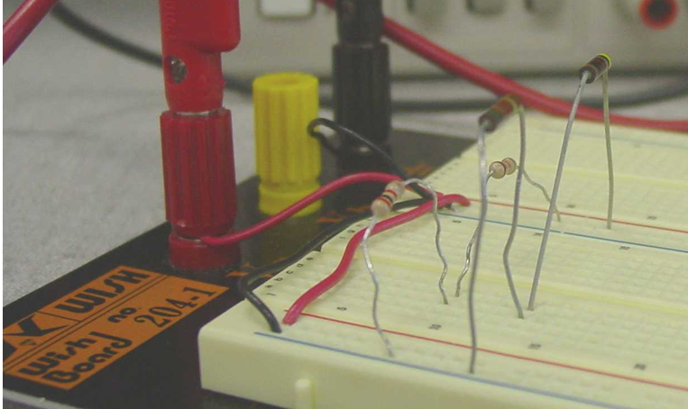
A
- (5 pts.) The picture above is from the guideline for Lab Experiment 1 (Introduction to the Mechatronic Engineering Laboratory), and shows a circuit that you will build next week. What should the nominal voltage be at lead A (of the resistor that is red-black-red)? What is the current through the resistor associated with lead A. You must show your calculations to have any chance at getting credit for this problem. [Hint: now would be a good time to read the guideline for Lab Experiment 1 and find the circuit schematic for this circuit (see Figure 11), because you probably can’t discern the color bands on the resistors from the photograph above.]
- (5 pts.) Visit the Reference section on the Arduino.cc website, and explain what happens if one does a digitalWrite() HIGH or LOW to a pin that is configured to be an INPUT.
- (5 pts.) Read the C Programming – Crash Review (http://www.engr.sjsu.edu/bjfurman/courses/ME106/ME106pdf/EBW_ProgrammingReview.docx) and the Embedded and Arduino vs. Standard C Programming (http://www.engr.sjsu.edu/bjfurman/courses/ME106/ME106pdf/EBW_EmbeddedAndArduinoVsStdC.docx) by Eric Wertz, and answer the following questions:
6a. One of the decision structures in C is the switch – case structure. What are some reasons why you might want to use it over the if – else structure?
6b. What is the single most important thing you can do make the time that you spend writing code efficient? What tool does the Arduino environment have to help you in this regard?
6c. What are the three most important reasons to use #define preprocessor commands?
6d. Are function prototypes needed in an Arduino program? Why or why not?
6e. Do you have to write a main() function in an Arduino program? Why or why not?
- (5 pts.) Consider the following scenario. Three ME 106 students, Dave, Carlos, and Vicki, work together on a homework assignment that includes a programming problem. Vicki and Carlos create a flowchart for the program, and they give it to Dave, who used to be a CompE major (but he switched to ME last year), because he has more experience than they do in writing C code, and Dave writes the program. Dave emails the program to Carlos, and Carlos assembles the flowchart and code, and emails the homework assignment to Dave and Vicki. They all put their name on the assignment and turn it in.
In light of the Academic Integrity Policy presented in the ME 106 syllabus, please comment on the approach taken by Dave, Carlos, and Vicki for this assignment. Are they in compliance? Did they plagiarize? Finally, what will you do in ME 106 if faced with a similar circumstance?

