RC Filters and Basic Timer Functionality
Learning Objectives:
The student who successfully completes this lab will be able to:
- Build circuits using passive components (resistors and capacitors) from a schematic diagram.
- Explain the concept of a high or low-pass filter and what its corner frequency is.
- Construct a low-pass or high-pass RC filter with a given corner frequency.
- Use and program the Arduino to produce audio with a speaker
- Explain how the hardware timer-counter peripheral inside the Arduino’s ATmega328 can be used to output a square wave with a given frequency.
- Learn how to time events using two different techniques with an Arduino
Components:
Qty. Item
- Arduino microcontroller board
- USB cable
1 Solderless breadboard
1 180Ω, 1.0kΩ resistors
1 0.1μF capacitor (may be polarized)
1 10μF capacitor (electrolytic, therefore polarized)
1 2W (approx.) paper-cone speaker (impedance TBD by you)
Introduction
RC Filter Theory
You will begin by investigating the influence of a simple circuit consisting of a resistor and capacitor on a waveform from the function generator (FG). Details of the construction are given in the Procedure below. First, consider the circuit shown in Figure 1. The impedance of a capacitor, Z_{C}, is 1/(jωC), a complex quantity, where j is the square root of -1, ω is frequency in rad/sec (2π rad/sec = 1Hz), and C is capacitance in Farads. Equation 1 below can be derived from the voltage divider relationship formed by the resistor and capacitor. Equation 2 solves equation 1 for the ratio of V_{OUT} to V_{IN} (V_{OUT}/V_{IN}), which is called the transfer function of the filter.
(1) (2)
The transfer function is a measure of how much of the input voltage is ‘transferred’ to the output. What happens to the value of the transfer function as the frequency of the input voltage increases? Does it increase or decrease? For a given sinusoidal input voltage V_{IN}, the magnitude of the output voltage V_{OUT} is given by the product of V_{IN} and the magnitude of the transfer function (evaluated at the frequency of V_{IN}).
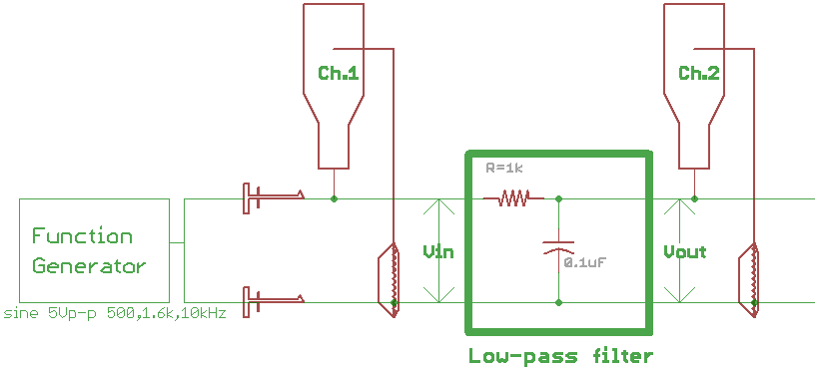
Figure 1. RC low-pass filter. The resistor and capacitor function together as a frequency-dependent voltage divider. The function generator will provide a time varying signal whose frequency can be varied, and the oscilloscope will enable you to measure the signal at the output of the filter circuit. Make sure that you use oscilloscope probes with the scope. Ask your lab instructor if you are unsure about which probes are scope probes.
An important property of filters is the corner frequency, or ‘cut-off’ frequency. This is the frequency at which the attenuation of the signal through the filter starts to increase sharply. For a passive RC filter, (high or low-pass) the corner frequency is 1/RC radians/sec. By substituting ω=1/RC into equation 2, you can see that the denominator goes to 1+1j, and consequently the magnitude of V_{OUT}/V_{IN} becomes 1/[ 1² + 1² ]^{1/2} = 0.707.
We will verify equation 2 by the following experiment.
Procedure:
1. Construct the single-stage RC Low-pass filter circuit shown in Figure 1 above. Pay attention to the connection of the leads of the capacitor. The curved line on schematic shows that the capacitor is polarized (which may or may not be the case depending on the type of capacitor you were given by your lab instructor). Not all capacitors are polarized, but electrolytic capacitors are. Electrolytic caps look like little aluminum cans. If you look at the side of the can, you should see a minus sign. The lead closest to the minus sign corresponds to the lead with the curved line on the schematic. It will also be the shorter of the two leads on a polarized capacitor, as long as no one before you has trimmed the leads on the capacitor! It is extremely important that the lead nearest the minus sign always be kept at a lower potential (toward ground) than the other lead of the capacitor. If you reverse the polarity, the capacitor can explode, so take extra precaution, and double-check how you have wired the capacitors before you apply power to your circuit. There are other capacitors such as ceramic capacitors (that often look like coated disks with legs) that are not polarized, so their leads are interchangeable. Know what type of capacitor you have, and connect it accordingly!
2. Set the function generator to output a 500 Hz sine wave, so that V_{IN} is 5 V_{P-P} (volts, peak-to-peak). Measure and record the amplitude of V_{IN} and V_{OUT} using the scope. Repeat these measurements with the frequency of V_{IN} set to 1.6kHz and then 10 kHz. Compare the ratio of the input voltage and the output voltage (i.e., V_{OUT}/V_{IN}) on the ‘scope with the magnitude of the transfer function (calculated from equation 2) evaluated at the corresponding frequency. What can you conclude from this comparison about the relationship between the magnitude of the transfer function and the ratio of the input and output voltages? Explain. Why is this circuit called a “low-pass filter”?
The phase lag of a circuit can be thought of as the amount of delay in the signal as it goes through the circuit. Phase lag is measured in degrees as shown in Figure 2. Recall that since the transfer function from equation 2 is a complex quantity, you can think of it as a vector in the complex plane. As you know, vectors have magnitude and direction. The phase lag of the circuit shown in Figure 1 is the angle of the transfer function vector, 1/(1+jωCR), evaluated at the frequency of the signal with respect to the real axis in the complex plane. We will verify this relation by the following experiment:
3. Using the scope, measure the phase lag of the circuit of Figure 1 at V_{IN} at 1.6 kHz. The following steps may help you make this measurement:
1). Use the position knob on the scope to center each channel around the horizontal (time) axis
2). Change the volts/div adjustment to maximize the size of the signals on the screen
3). Adjust the Horizontal Delay to center a peak (or zero crossing) of the V_{IN} waveform on the vertical axis
4). Using Measure buttons, determine the period of the V_{IN} waveform
5). Use the Cursor button and cursors for t1 and t2 to determine Δt between the peaks (or zero crossings) of V_{IN} and V_{OUT}
Take a picture of the scope trace for the lab report. Does the theoretical value match the observed value?
Full period
t1
t2
Δt
Figure 2. Phase lag of V_{OUT}. The output voltage is delayed (shifted later in time). The amount of time shift depends on the value of R and C, and the frequency of the input signal. One period of the waveform represents 360º, so the phase shift is just the percentage of time delay multiplied by 360º. You can use the time cursors on the scope to help in making the phase lag measurement.
4. Construct the single-stage RC high-pass filter circuit shown in Figure 3, and verify (using the voltage division formula) that V_{OUT}/V_{IN} for this circuit is as follows:
(3) (4)
- Repeat steps 2 and 3 for the high-pass filter in Figure 3. Note that V_{OUT} is measured across the resistor in this case.
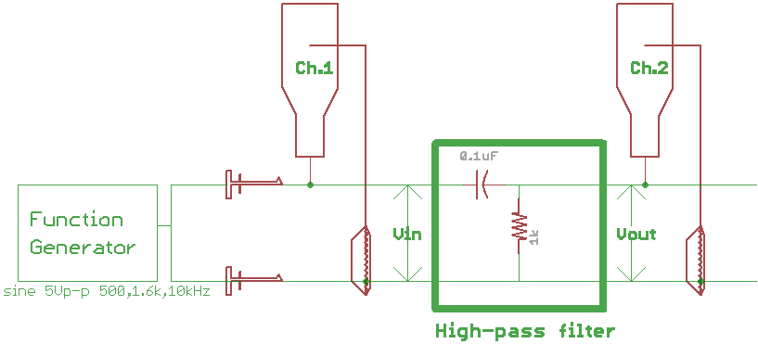
Figure 3. High-pass filter. The resistor and capacitor together function as a frequency-dependent voltage divider. Note that the locations of the resistor and capacitor are interchanged in comparison to the low-pass filter shown in Figure 1.
Add a DC offset (any value) to the function generator output. Does this DC offset affect the output (V_{OUT}) of the high-pass filter? If so, how? Record your measurements for V_{IN} and V_{OUT} after you add the DC offset. This is the reason that a capacitor can be thought of as a device that blocks the DC component of a signal. Using a series resistor like this is called AC coupling, that is, coupling only the AC component of the signal from one side of the capacitor to the other.

Using the Arduino to Output a Frequency
Basic introduction to IC timer-counters
One of the most common and useful peripheral devices in a microcontroller is the Timer-Counter. A timer can be used to measure amount of time between two signal pulses. Alternatively, a counter can be used to simply count the number of pulses in a pulse stream. An example for the former case would be measuring the speed of a rotating wheel with a fixed sensor that gets a pulse for every revolution of the wheel. By timing how long it takes between pulses, one can determine rotational speed. Similarly, by counting the pulses and knowing the wheel's diameter, one can compute distance.
Timer-counters are also extremely useful for generating their own output pulses when paired with a clock signal. A clock signal is simply a very (very) consistent train of pulses generated by a device at a constant frequency, such as that shown in Figure 4 below. These clock signals are themselves generated from either crystals or RC oscillators tuned for particular frequency. You have probably heard of the clock speed of a computer or microprocessor. You can think of the clock signal as the heartbeat of a sequential logic device, or a rotating gear that drives a number of other gear-shafts in a mechanical apparatus.
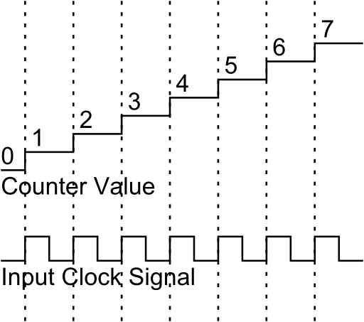
Figure 4. Clock signal input to a counter and the resulting count value as a function of time. Each time the clock signal has a rising edge, the counter's value increases by one.
A timer is really a specialized counter that is always fed a uniform, reliable clock signal. A timer increments an internal register (a register is basically a specialized memory location) each time the clock signal changes on a rising-edge, or a falling-edge. The counter increases until it reaches a maximum value known as the TOP value of the counter. The most basic counters are unidirectional, which means that they will only count up or down, starting from either the TOP value or the BOTTOM (minimum) value. A unidirectional counter (either an up-counter or a down-counter) will overflow on the next clock pulse after it has reached its top or bottom value, and it will then reset to the respective opposite value. There are also up-down counters which count to a TOP value, and then back down to the BOTTOM value.
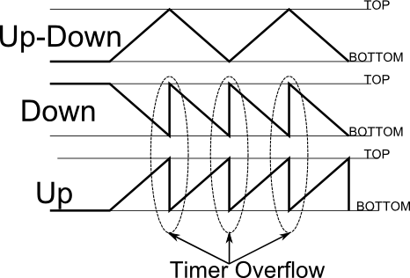
Figure 5. The three main types of counters and their count values as a function of time. Note that 'up' and 'down' counters will loop around from top to bottom, this is called an overflow.
The ATmega328 microcontroller used in the Arduino features three built-in timer/counters. These are independent peripherals (circuit) units within the microcontroller, and function autonomously, which means your program code configures the attributes of the counting operation and simply starts the timer running, after which it runs until turned off or otherwise changed. These configurable attributes allow you to choose between clock sources (which might be the chip’s on-board clock or some other external clock signal), how it should count, and whether it should behave as an up, down, or up-down counter.
The ATmega328 features two 8-bit counters (Timer0 and Timer2) and one 16-bit counter (Timer1), and the resolution of each counter may optionally be modified by the use of a prescaler. A prescaler allows one to scale down the clock signal by a specified ratio. In mechanical terms, the prescaler acts like a reduction gear on the rate of speed of the input clock. Note that because it is the post-prescaled pulses that are counted, the minimum increment of time is one input clock period times the prescaler value.
For example, a chosen prescaler value of 8 used with Timer0 means that only every 8th clock pulse will cause the counter to be incremented. When used with the standard 16 Mhz clock tick, the counter will only increment at a rate of 2 MHz. Consequently, one counter tick is one two-millionth of second (0.5 microseconds), and that is the resolution of this configured clock. The size of the clock (8 bits for Timer0) means that the longest period of time that you can measure is 256*0.5 microseconds, or 128 microseconds. Counting for longer periods of time is possible with this (or any) prescaler value if you go to the extra trouble of maintaining a separate count of the number of times that the counter rolls-over. This is essentially what the millis() function does, which you will learn about later in the lab. If we are using a 16-bit counter and the above mentioned clock and pre-scaler, how much time will it take for the counter to reach it maximum value and then overflow?
In the Introduction to Arduino lab, you have already seen three uses of a timer peripheral within Arduino library functions – delay(), AnalogWrite(), and tone(), whether you realized it or not. You should remember that delay() was used to pause the program (doing nothing) for a specified number of milliseconds. Also, that AnalogWrite() is used to generate a series of fixed-frequency (490Hz) pulses at a specified duty cycle. And finally that tone() is used to generate fixed-duty-cycle (50%) pulses at a specified frequency. It is important to understand the difference between how AnalogWrite()and tone() work – one is fixed frequency and variable duty-cycle, and the other fixed duty-cycle and variable frequency.
You may also remember that once you called tone(), it continued to generate an output tone until either noTone() was called, or until you reset the processor – the timer-counter ran completely independently once started, in parallel, with the rest of your program. This is a standard feature of a peripheral in a microcontroller – it's a dedicated mini-microprocessor that is able to perform some specialized function after it is started, and runs autonomously until its task is completed.
The Arduino library function tone() greatly simplifies the use of the timers for generating audio tones by setting up the timer-counter the first time it is called in a program. You merely specify on which pin to generate the (square-wave) tone signal and the frequency to be generated, and it just goes without any more attention.
Driving a Speaker with the Function Generator
You will begin this lab by measuring the impedance of the speaker that we will be using in this lab. Set up the DMM to measure the DC impedance of the speaker as shown in Figure 6.
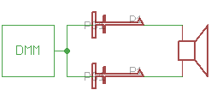
Figure 6. Measuring the impedance of the speaker. Set the DMM up to measure Ω 2W (two-wire resistance measurement). Probe across the two leads of the speaker. Most paper-cone speakers are in the 4-50 Ω range.
Set up the function generator (FG) with a 1V peak-to-peak (V_{P-P}), 0V offset, sine wave signal. Because the speaker is a low-impedance load, setting the FG for a 50 Ω output impedance rather than Hi-Z is more appropriate to get the best approximation of the actual output signal voltage. Attach the oscilloscope as shown in Figure 7 so that you can observe the waveform from the function generator.
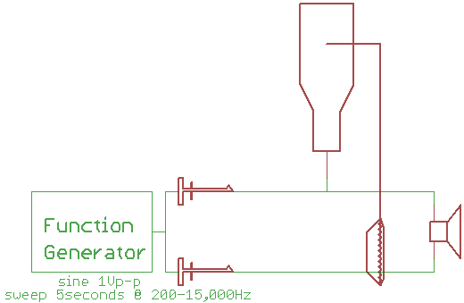
Figure 7. Setup for measuring output from the function generator to the speaker. Connect a scope probe to one lead of the speaker, and the alligator clip from the scope probe to the other lead of the speaker.
Use the knob on the FG to increase the frequency to the point where you can no longer hear the tone from the speaker, and record this value in your lab report. This frequency can vary from person to person, and tends to be determined primarily by age, health conditions, medications (just ask Rush Limbaugh), and accumulated noise exposure, but is also a function of the construction of the speaker itself.
Now we are going to set the FG to sweep frequencies from 200-15,000Hz. The sweep is established using the FG with following series of steps:
- SHIFT, MENU, RIGHT-ARROW to select SWP MENU, then down to enter.
- You should now see “START F” (start frequency). Press DOWN-ARROW, then RIGHT-ARROW/LEFT-ARROW until the hundreds digit is flashing.
- Use the knob to set the frequency to 200. To get out of this menu, but to stay within the sweep menu options (rather than pressing ENTER which commits the value, but throws you out of the menu system), press LEFT-ARROW until the caret (^) symbol appears, then press UP-ARROW to back-up just one menu level.
- At the same menu level as “START F”, there is a “STOP F” to set the stop frequency. Navigate (down) into there and set the frequency to 15 kHZ. Back-up one level with the caret trick..
- Similarly navigate to the “SWP TIME” option and set sweep time to 5.0 seconds. Since you are done with setting sweep options, pressing ENTER is the fastest way to commit your changes and get out of the menu system.
- Press the SINE-WAVE button, then SHIFT, SWEEP to start the frequency generation. At some point future point when you want to turn off sweep, SHIFT, SWEEP will toggle it off.
Describe what you hear on the speaker. Now observe the oscilloscope display. Press Auto-scale to get the waveform scaled vertically for the screen. After noting the default-scaled waveform, for a better view switch the horizontal scale to 2.00ms/division using the HORIZONTAL Time/Div knob. Describe what you see on the scope. Now switch the waveform from sine-wave to square-wave on the FG, and compare this tone to the sine-wave tone. Describe any sound difference that you hear. Can you think of any reasons why sine-wave audio might be preferred to square-wave, and vice-versa?
Now we want to replace the function generator with the Arduino and use it to output audio to our real speaker. Note that this particular speaker does not have positive and negative leads – they are interchangeable.

- Build the circuit shown in Figure 8 on the solderless breadboard. The current-limiting resistor is present to ensure that you do not exceed the 40mA (absolute maximum!) current rating of an ATmega’s I/O pin. To what value will the current be limited with the speaker and 180Ω series resistor shown in the figure?
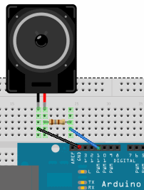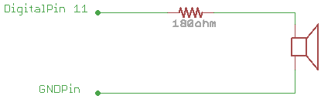
Figure 8. Arduino connected to speaker with current-limiting resistor. You must always ensure that there is a common ground between the Arduino and the breadboard circuit, otherwise you will (always!) be unable to make a proper measurement.
- Create a new sketch using the Arduino IDE that generates a sweep tone similar to the one you generated with the function generator (minHZ=100, maxHZ=15000Hz, over 5 seconds. You may start with one of the tone-related examples provided in the IDE from last week, since most of you are still probably not up-to-speed yet creating code from scratch. If your first attempt sweeps too quickly, you may have to slow it down using either delay() or delayMicroseconds(), which like all Arduino library functions, are documented in the Reference section of the Arduino website. Hint: You will probably want to use a for loop to complete this exercise. Include the code in your lab report.
- Add some code to time the sweep sequence and to print the result on the Serial Monitor. Clearly this will involve the use of the Serial object from the Arduino library that you were exposed to last week, but it will also require the use of an additional function, millis(). The idea is to record the starting and ending times surrounding an event and to compute the difference. This technique demonstrates the most straightforward way of measuring the time between two events. Include the code in your lab report.
- Disconnect the Arduino from the solderless breadboard circuit, because we are done using the breadboard now. Set up the function generator to produce a square wave with 5 V_{P-P} amplitude, 2.5 V offset, 50% duty cycle, Hi-Z termination, for any frequency between 1 kHz and 5 kHz. Verify that you get a square wave between 0-5 V on the oscilloscope – voltages out of this range can (really, not hypothetically) easily fry the microcontroller. After verification, connect the function generator to Digital pin 11 (and ground) on the Arduino. Create a sketch that uses the pulseIn() function to time the length of the high portion of the signal pulses from the function generator and print it out on the Serial console. Document the frequency you have chosen, and the values printed by your program for at least 10 pulse length captures, as well as their average. Compare the observed average value of the measurements versus the expected value from the function generator frequency you have chosen. Document all your settings, measurements, code, and a screenshot of the serial console from this exercise. This technique may be useful for your term project because some sensors report their measurements as pulse lengths and/or duty cycles rather than directly as analog or digital values.
Speakers are a classic transducer, a device that transforms energy of one form to another. In the case of a speaker, electrical impulses are transformed into electromagnetic mechanical displacements of a paper cone disturbing air resulting in sound. Light bulbs are another example, except that their output is light (and waste heat). Many transducers work in both directions. This is a common, but not universal, feature of transducers: their less than ideal – but viable – reversibility. Speakers are microphones when reversed, picking up (sensing) sounds and turning them into electrical pulses. LEDs similarly have the ability to detect light, rather than to produce it, when reversed.
Not only can the “microphone” be displaced by air (sound), but also by vibration coupled into the speaker ring with respect to the magnet – both viable sensing mechanisms for you to use, although some amplification is often necessary (at least for an inverted speaker). Piezo speakers (like the one on the Spartan Experimenter Shield) are often used as knock sensors because they are readily able to detect taps/knocks on surfaces. Their advantage over magnetic speakers in this application is that they are able to produce high voltages when disturbed, better than electromagnetic speakers.
- (Optional, if time permits) Hook-up the speaker leads to one of the probes on the oscilloscope. Set the scope for 100 μs/div (or so), and 10 mV/div. Try to speak/sing into the speaker at a fairly constant frequency that you're comfortable producing at a moderately loud level, and you should see a waveform on the scope. Try varying your tone and document both the range of frequencies you can generate, and at what amplitudes. Feel free to adjust both the vertical and horizontal scales on the scope to fit your input levels.

The letter j is used rather than i for the square root of -1 in Electrical Engineering because i is used to signify current.

