ME 190 Lab 2 – PSoC-to–MATLAB Integration

Learning Objectives
By the end of the lab, you should be able to:
- Have a working installation of PSoC Creator 3.2 (SP1) installation that is capable downloading to, and debugging code on, a CY8CKIT-044 development board
- Build and run both unmodified and modified, PSoC Creator example projects on target hardware
- Set up serial communication for passing data between the CY8CKIT-044 board and MATLAB running on your PC
- Use MATLAB to visualize 3-axis data gathered from the board's built-in accelerometer
Requirements
CY8CKIT-044 PSoC 4M Pioneer Kit
MATLAB installed on PC
Windows (possibly virtual) PC for running PSoC Creator
Introduction
This lab is intended to be both a continuation of last week's MATLAB refresher lab and a segue into next week's more complete PSoC Creator and PSoC 4M Pioneer kit lab. It builds on last week's lab by using MATLAB's graphing capabilities to visualize data generated by the 3-axis accelerometer built-in on the microcontroller board. During the course of enhancing one of Cypress' demo program to get the data to MATLAB on the PC, you'll learn the basic steps of how to build, download and run a PSoC Creator project on your hardware. Next week's lab will be a more complete treatment of both the PSoC software and hardware.
Pre-Lab tasks
Part 1: Watch intro videos
You should try to watch as many of the PSoC Creator 101 videos as possible before this lab. The initial videos will guide you through the installation of the software and introduce you to this (very, very different from the Arduino) development environment. You should watch at least the first four video lessons. Although the presenter is using is the PSoC 4 Pioneer Kit (CY8CKIT-040) board (“kit”) rather than the 044 board that we're using, these two boards are much more similar than they are different.
Part 2: Download and install PSoC Creator and kit-specific file sets
Download and install PSoC Creator as described in Appendix A.
Part 3: If you're a MacOS user
Read Appendix B if you're a MacOS user to find out what you may or may not be able to do without Windows for the MATLAB portion of the lab.
You will likely need to install a program like PuTTY, ExtraPuTTY, or TeraTerm to get serial access to your board from the PC if you have no such program already.
Exercises
Step 1: Ensure that you can build the Cypress-provided accelerometer demo application using your recently installed copy of PSoC Creator and your (PsoC Pioneer 4M) 044 board.
After installing PSoC Creator, go ahead and fire it up. You should see a screen similar to this:
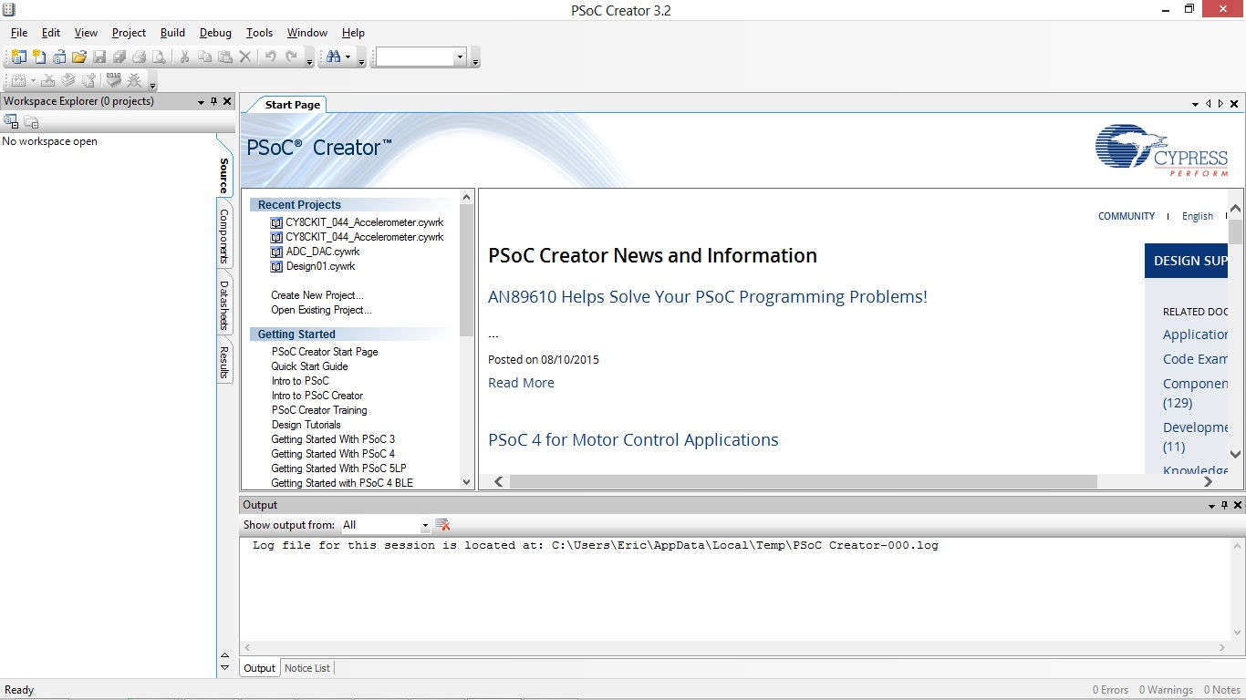Illustration 1: PSoC Creator 3.2 Start Screen
Scroll down in the list window containing Recent Projects, Getting Started, etc and open the subtree for Kits in Examples and Kits by clicking the “boxed plus” symbol. It will open-up a list the kit-specific code packages that you've already installed. Open up the subtree for CY8CKIT-044 to see the Cypress-provided example/demo programs that have been installed.
There is an example that makes use of the accelerometer – how convenient for us since that's perhaps something that we can start with for our own project here today. Click on CY8CKIT_044_Accelerometer to load that project into the IDE.

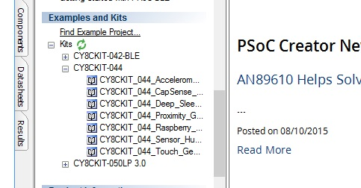Illustration 2: PSoC Creator 3 Examples/Kit List
You will then be asked to choose a directory in which to put your own copy of the example project for building and making your own modifications. Although you can place it “anywhere” you like, I choose My Documents\PSoC for all of my PSoC projects.

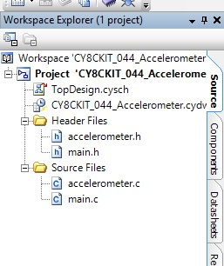Illustration 3: Accelerometer demo workspace view
After a moment you will have your own copy of the project, parts of which will be listed in the Workspace Explorer window along the left edge of the display. Since this is our own copy of the project, let's give it our own name. Right-click on Project 'CY8CKIT-044 Accelerometer...', choose Rename and change it to Lab2-UART-MATLAB. While we're at it, let's also change the name of the workspace from 'Y8CKIT-044 Accelerometer... to ME190. Going forward we're going to try to keep all of our labs together in this ME190 workspace.
While we're at it, go to Tools->Options->Project Management and enable Reload the last workspace on startup and press OK.
Note that a project is (initially) composed of three groups of files: the two Cypress PSoC project configuration files (*.cysch, *.cydwr), C-language header (*.h) files, and C-language source (*.c) files.
To view source code files in an edit window, double-click on (for example) main.c. A new window will open for the code and the right-hand pane will show a tree full of interesting properties of the file that you're viewing, in particular the include files, function names and variables declared in the file in the source code window.
Double-click on the main(): int entry about two-thirds of the way down this list. It will move your cursor to the first line of the declaration for the main() function in the source file window. Welcome to a few of the approximately 800 useful things that real IDEs (that is, non-Arduino IDEs) like PSoC Creator do for you.

To compile the entire project from source to the point where it can be downloaded to the board, choose Build->Build CY8CKIT-044 Accelerometer in the main menu.

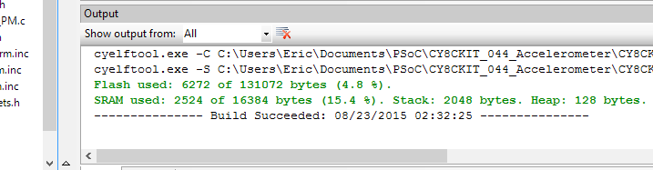Illustration 4: Telltale signs of a successful project build
After these few moments, the contents of the Workspace Explorer pane on the left should explode into a much larger set of source file inside a new Generated Source subtree, along with the original six files you started with. What has happened is that all of the other code required to complete the build of your project (and the system) has been generated and compiled together your source files into a downloadable and executable binary file for the board. This is roughly similar to what the Arduino IDE does for you when you click its (non-intuitively named) Check or Upload button. Once complete you should see the following:

Some of this generated code will likely remain impenetrable to you for a long time, but if you scroll down farther you'll see some code file subtrees that may look a little more familiar, or at least approachable, like I2C, Pin_Accelerometer_Interrupt, Pin_BlueLED, PWM_Blue, etc. All of the code generated throughout this section has been specified in a different file which you'll be introduced to momentarily.
Step 2: Figure out what this demo actually does
There are a few different ways of trying to figure out what this demo is doing. You can always simply start the program and guess what it might be doing, but sometimes a little actual work can save you a lot of time guessing. The two more obvious ways to start would either be to look through the code and its comments, or to read any documentation that may have accompanied the demo. Fortunately there is a (PDF) User's Manual for the 044 board that contains a lot of very useful and important information about your hardware. You will be referring to this throughout the semester, so start by tracking it down.
There's probably some fancy way to find the documentation from within the IDE, but I wasn't quickly able to find how, so I just looked for it where PSoC Creator was installed on disk. In \Program Files (x86)\Cypress\CY8CKIT-044 PSoC 4 M-Series Pioneer Kit is everything having to do with this particular kit – documentation, examples, board manufacturing files, etc. Hunt down and open CY8CKIT-044_Kit_Guide.pdf. Skip down the Section 4 Example Projects and read Section 4.7 for the Accelerometer demo that we've loaded into Creator and are threatening to download and run on our board.
If the documentation doesn't provide you all of the information you'd like/want once you start running the demo on the hardware, you may very well have to look at the code itself to answer your remaining questions. As you'll soon see, part of the design/code for a PSoC project is in its schematic diagram, so there might be some interesting comments hiding in there also.
Q: What causes the program to read and display the accelerometer data, that is, does it quickly and continuously update, intermittently poll for data, or only when some even causes something to happen?
Q: What is the expected output – how is it displayed/represented?
While you have the board's user guide open, take a few moments and have a look at its table of contents so that you know what information you can expect to find here. It also couldn't hurt to take a look at the overview section(s) to see what's built-in on this board and what other demos are ready for playing with in the future.
Just to delay gratification a bit longer, go back to Creator and have a look at that main() function we just moved to.
Q: Does this match your understanding from what you read in the Kit Guide? Why or why not?
Q: After looking at the code, what do you think the prospects are for getting the X/Y/Z data out from inside this demo program and ultimately off of the board back to the PC? Why or why not does this demo look like a viable starting point?
Step 3: Ensure that you can run the unmodified Cypress-provided accelerometer demo application on your 044 board.
Connect the board to your PC with the supplied USB cable. The first time that you do this a driver may need to go through some type of installation process. Once the driver installation is complete you should be able to select Debug->Debug from the main menu, followed few moments later by an indication in the Output window that the download to the board was successful. Creator will then switch to Debug mode and then stop at the beginning of main() before starting to run your program. Stopping here before starting to run gives you the opportunity to take control of the debug session and either run the program statement-by-statement, or letting the program free run. We aren't going to do any debugging now, so just press the Resume button
to let 'er rip. You should see some response from the board that you read about in the kit guide. Note that due to the force of gravity, you'll always see a full 1g acceleration vector shared among one or more of the X/Y/Z dimensions. Try to orient the board along each of the three X, Y and Z axes with respect to gravity while both holding it still and then moving it up-and-down as vertically as possible.
Q: Are there any things that you can do which result in the board's output response to not be what you'd expect/like?
To return to the regular source viewing window(s) in Creator you can click the Stop Debugging icon, the square icon near the Resume button you just pressed.
Q: Does the board's program continue to run after you press “Stop Debugging”?
Step 4: Getting to know PSoC Creator's Schematic Editor project view
Double-click on TopDesign.cysch in the Workspace Explorer window. This opens the graphical representation of your project's components. The contents of this window should not be a total surprise if you watched the pre-lab videos. The contents of this window contain the references to the components that make up this demo project. Note that there are multiple tabs at the bottom of the window that make up the full contents of this design space, one each for Accelerometer and LED Control.
You can see from this example schematic design that it's possible to get pretty fancy with your design drawings by adding labels and other embellishments to them. Similar to what the MATLAB Publishing features is trying to do for you, the idea is to encourage and make it easier for you to make or derive your documentation directly from your code and/or schematics. The age-old problem that has been observed in programming is that if the documentation and technical data are maintained separately, they're much more likely to become out-of-date with each other.
To be able to transfer motion information from the board to the PC for massaging in MATLAB, we'll have to add another component to our design. Although it's possible to introduce another tab to the schematic for us to add our one UART component, we're going to hijack part of the Accelerometer's schematic page. We're just going to move things around to make some room.
Start by selecting the label I2C 3-axis Accelerometer and then drag-and-drop it so that it's more flush up against the left edge of the sheet. Do the same for its friend, the schematic component labeled I2C. You should end up with something that looks like this:

In the Component Catalog window along the right-side of the screen, expand the Communications subtree. Drag-and-drop the UART (SCB Mode) label to the right-hand side of the sheet where we just made room for it. Click on the T (for Annotation Tool) in the vertical icon list on the left edge of the schematic window to add a text label for our UART component. Label the UART icon above with UART to PC. To quit adding text to the input field, click somewhere else in the schematic. Right-click on the new label and select Format Shape, expand the Font tree and change the font size to 24 to match the other labels' size.
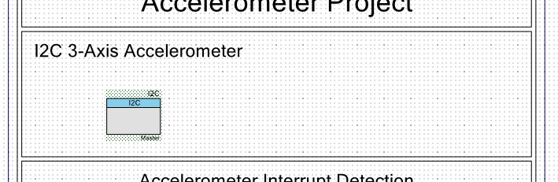Illustration 5: Schematic editor view after making room for a new component
Double-click on the UART icon to configure this new component. In the Configuration tab, ensure that UART is selected. In the UART Basic tab, change Name from UART_1 to UART, and change the Baud rate to 9600. Note that the Data bits, Parity and Stop bits are 8, None and 1, respectively. Click OK. As you should remember from your previous microcontroller experience, asynchronous communications require both sides of the connection to agree on the speed and all other configuration parameters to communicate successfully.
Open CY8CKIT-044_Accelerometer.cydwr in the Workspace Explorer. In the right-hand window, assign the pin for UART:rx to P7[0] and for UART:tx to P7[1]. You may need to pull or horizontal-scroll the pin assignment window wide enough to see the rightmost columns, which is where all of the action is.
Step 5: Determining the name of the device file to the board from the PC

Track down which COM port is currently associated with USB-UART bridge to the board. Inside Windows' Control Panel, find your way to the Device Manager. Expand the subtree for Ports (COM & LPT) and look for the entry labeled KitProg USB-UART. In parenthesis is the COM port name/number used by the PC to communicate (over a virtual serial connection over USB) to the board. Remember this COM port name – mine is COM11 as shown below.

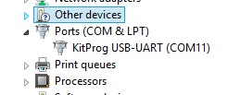Illustration 6: Determining the COM port used to communicate with the board

NOTE: I highly encourage you to consider typing-in code snippets manually throughout the lab where you're asked to insert text rather than using cut-and-paste. The reason is that depending on what program(s) you're cutting-and-pasting from you can get spectacularly difficult to find invisible characters injected into your source files which will cause them not to compile. The only exception to this is the text for the comments which you may be able to get away with cut-and-pasting. If you want to try to cut-and-paste and it isn't working for you, delete what you've pasted and enter the text manually.

Step 6: Verify that you can programatically get a single string of characters sent from the PSoC board to the PC and displayed in PuTTY.
In main.h, around where all of the other #define lines live, add:
#define EOL "\r\n" // \r\n for Windows, \n for MacOS/Linux
In main.c, after the call to InitializeAccelerometer(), add the following:
while (1) {
UART_UartPutString("excellent!" EOL);
CyDelay(1000); // 1 second
}
After the call to I2C_Start() in Initialize_Project(), add:
UART_Start();
Build the project (again, Build->Build...) and download it to the board (Debug->Debug...), and let it free-run (Resume).
Step 7: Run your terminal emulator of choice to open a serial connection to the board
If you're using some flavor of PuTTY, first, select Serial as the Connection Type. Only after you've done that can you then set 9600 as the speed, and the right COMnn as Serial Line. In full, the serial connection parameters are 9600-baud/8-bits/No-Parity/1-stopbit (a.k.a. 9600/8/N/1) if you're using something else. PuTTY defaults the other parameters to 8/N/1 for us (in Connection:Serial), so you should otherwise be set.
If everything goes well you should see the sample messages printed out in the terminal emulator window. If not, you've either gotten an error or you're simply getting no output. If it's the former, the error message is hopefully telling you something useful. If it's the latter, confirm that your terminal settings are correct, and perhaps press the reset button on the board to start the program. If you're still having problems, have your neighbor put a second pair of eyes on it, and then finally the TA if you're both stuck.
You should see a nice line-after-line sequences of messages. If you're seeing each successive line march across the screen in a staircase fashion, you either don't have the right EOL definition set, or perhaps there's a setting in your terminal emulator having to do with EOL/end-of-line that needs to be tweaked.
Q: You may/should have noticed that the RGB LED isn't responding to board movement anymore. What is it about this change that prevents this from working now?
Step 8: Take out the test message and send the 3-axis accelerometer data.
In main.h, add
/*
* C/C++ allows you to build-up a constant string as the concatenation of other
* constant strings. For example, specifying a string "ab" can also be formed
* with "a""b". We're using this feature to put the right EOL character(s) onto
* the end of the strings below. NOTE THAT THE %lu is “percent-ELL-u” not “percent-ONE-u”.
*/
#define XYZDATA_FORMAT "ACC %lu %5d %5d %5d" EOL
/*
* Determine the worst-case amount of space necessary to hold the formatted string
* (header, 32 bits of msecs, 3 * (sign + 11 bits of accel), EOL, NUL-terminator
*/
#define XYZDATA_STRLEN sizeof("ACC tttttttttt -xxxx -yyyy -zzzz" EOL "\0")

Because the libraries that come with PSoC Creator don't seem to have a handy millis() function like Arduino's, I've come up with one that comes in a pair of files millis.h and millis.c. Both of these files can be downloaded from either the course website or Canvas.
The trick is getting these files into your Creator project. The least error-prone way of doing this is to download millis.zip and extract millis.c and millis.h from it. What you are going to do now is to take these two files and move them into the same directory as your source files (main.c, main.h, etc) – the trick is finding that directory...
If you took my suggestion about where to store your Creator projects above, you can find your source files somewhere that looks similar to the following:
My Documents\PSOC\CY8CKIT_044_Accelerometer\Lab2-UART-MATLAB.cydsn
If you chose a different directory to store your Creator files, then start looking there. The key is that once you've found main.c, main.h, accelerometer.c, etc., you've found the directory into which you should move your millis.c and millis.h. Move them there now.

In Workspace Explorer, right click on Header Files and select Add->Existing Item and select millis.h from the location into which you just moved your files. Similarly, with millis.c, add this existing item to Source Files.

From here on, all of the remaining changes are to be made in main.c.
Remove the while loop with the UART_UartPutString() call that you inserted in the previous step.
After the existing #include lines, add:
#include <stdio.h> // for sprintf()
#include “millis.h” // for millis*()

After the call to UpdateLEDColor(), add
/* Send out XYZ-axis data through UART to PC */
{
char s[XYZDATA_STRLEN];
sprintf(s, XYZDATA_FORMAT, millis(),
uC_Probe_x_dirMovement, uC_Probe_y_dirMovement, uC_Probe_z_dirMovement);
UART_UartPutString(s);
}
In Initialize_Project() at the end, add:
(void) millis_Start();
Build, run and watch the output come out in your terminal emulator.

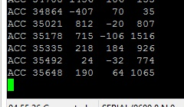Illustration 7: Timestamp and 3-axis accelerometer data displayed in PuTTY

Step 9: Hook it up to MATLAB
Now that you're clear on the format of data coming from the board, you need to read this data in line-by-line and to implement some type of visualization for it in MATLAB.
What you're basically trying to do here is to open the COM port and read the lines in that contain “ACC <timestamp> <x> <y> <z>” that you've already seen wtih PuTTY. From MATLAB's perspective, in many respects it is just like trying to open a file full of data for reading.
The easiest way to start is to simply ensure that you can read in the individual lines of text, and only after that worry about doing anything meaningful with the data. First you'll need to investigate how to open the appropriate COMnn device file and to read in the lines one at a time. Before getting too fancy, consider just printing out the string from MATLAB to ensure that you're OK before going any farther.
Once you've figured out how to do that, figure out how to split each line of text once it's read in, into the multiple fields that are space-separated. Most language libraries have a function to do exactly this – you give it a line of text and it hands you back an array of strings, one for each field.
The first field, “ACC”, is there for two reasons. First, so that you know what type of data is contained in that line (accelerometer data), should you choose to start sending multiple types of data from the board in a future revision of the program. Secondly, since this first field has “pre-known” contents, you can/should check it to make sure that the data that you've read isn't obviously corrupted.
Once you've split the lines' contents up into its constituent fields, do something intelligent with (at least) the three axes' data. You might choose to plot that data in 2-D, one distinct color for each of X, Y and Z in a +/- 3g-versus-time plot. You could also try to find a 3D visualization example to adapt that generates a visualization in 3-space (ideally something that looks like rectangle denoting the plane of your board), perhaps something to this).
Step 10: Publish the code and your plotted output from MATLAB and make sure that you include it in your lab report.
Step 11: Future ideas for improvement
You probably have noticed that the demo has made some design or implementation decisions that aren't optimal for our purposes.
Q: What two significant features/design-decisions in the original demo would it be nice to change? How or why would these be an improvement on what you're running now?
Try to make these changes in a cloned copy of this project in your copious spare time.

Appendix A - Installing PSoC Creator
PSoC Creator is the collection of tools required to build projects for PsoC microcontrollers. It is made up of the tools that generate code and internal connection routing for the MCU itself as well as the open-source GCC compiler tools and the programs that facilitate download of executables and their live debugging. Not all of these tools necessarily have to run within Creator, but for all intents and purposes for this course, they will. So we'll refer to what Creator does is pretty much everything that produces programs for the PSoC.
PsoC Creator may be used to develop software for PSoC3, PsoC4 and PsoC5. We will definitely be using PsoC4 in this course and may be using PsoC5 later in the semester. We will not be using PSoC3, and for reasons mentioned below, it may be preferable to excluding loading software having to do with PSoC3.
It should be noted that PSoC Creator is a Windows-only application. For a discussion of how some portions of this lab may be performed under MacOS, consult Appendix B.
Downloading the software

Execution of this lab requires download of both the integrated development environment (IDE) from Cypress, PSoC Creator, as well as the kit (board)-specific files containing the configurations, demos, examples, etc.
Be aware that downloading anything from Cypress requires that you be logged into a Cypress account. However, account signups are both free and relatively painless (I did it so long ago I don't remember what's involved anymore). Also be warned that for everything that you download, at some point you'll get an automated follow-up email asking you for feedback on whatever it was that you downloaded.
Although there is a installation “mega-bundle” linked-to from the CY8CKIT-044 product page on Cypress website, it has bundled within it an older copy of PSoC Creator. Were the download for PsoC Creator not so large, it might make sense to install from this mega-bundle and then update Creator. Unfortunately this takes a lot of time to both download and (uninstall and) re-install, so we're going down another route. This other way is possible because it appears that all of the Cypress software installers are smart enough to know that when they contain older software than you already have installed, to not squash a newer copy that you have already installed.
Start by downloading and installing the latest-and-greatest PSoC Creator, then just the kit-specific files. From here download PsoC Creator and install it. You will be given the option to use a smart download manager (Akamai NetSession), or if you cancel out of it, to just download the software directly. The advantage of the former is that if your download is interrupted, it won't have to start the download over from the beginning again. Once the download is complete, begin the installation. A most excellent alternative to downloading it yourself is to score the ~600MB installation file from someone else that has it.
Upon running it, first you'll have to choose an installation type -- Typical is “OK” for use with the current board – but selecting Custom and only un-checking the option for Keil PK51 PDK is even better. If you don't exclude installing the Keil PK51 PDK, at some point in the future, every time that PSoC Creator starts up, you have to close a nag screen that comes up telling you to register that expired software. Because it's something that's only used with PSoC3 (which we're not using anyway), it's an annoyance that can be avoided, so just avoid loading it altogether.
Continue on and accept all of those license agreements. Let the software install and when it finally asks you if you want to look at any of the release notes or to run Creator or the Update Manager, un-check them all and press Finish.
The kit-specific files for the board that we're using can be gotten from here. Down in the Related Files section, choose to download the CY8CKIT-044 Kit Setup 28MB file. Were you to download either of the larger files (as of today), you'd be downloading a bundle that contains an older version of Creator than the one that you just got. Run through a typical installation to the end. If at the end you are given the option to run either the Update Manager or PSoC Creator, go ahead and choose to run whichever it's offering (if both, Update Mangager wins). If you blitzed through this final screen, just run PSoC Creator from the Windows Start menu.
If you're in Creator, select Help->Update Manager, then close Creator after the Update Manager is up. If you're already in Update Manager, you're good.
If you don't do this then you'll be asked to close Creator at some point anyways if/when Update Manager tries to update Creator itself. If there's anything that you've just loaded that is less than latest-and-greatest, Update Manager will show you some non-greyed-out Update buttons that you should click on (sequentially, not so all of them run at the same time) to update those components. If Creator itself needs updating then at some point you'll be asked to close it so that it can be updated. Upon completion, every product's Update button will be greyed-out and say No Updates and you'll be done.

Appendix B - MacOSing with the PsoC

For the most part you're on your own if you're a MacOS users because none of the instructors/TAs are Mac users. That being said...
Because PSoC Creator is only offered on Windows, any part of the lab (or the whole course, for that matter) having to do with programming the PSoC will have to be done on Windows. There should be no problems running BootCamp to get to Windows, so if that's OK with you, that's absolutely the way to go.
There is one point in the lab that once you have the correct data being produced by the board and sent over the serial link that you should done with Windows for the day. Running Windows under BootCamp and MATLAB under MacOS could be problematic because until you “get it right” you may need to go back and forth between the two operating systems, which is probably going to be painful.
In theory one can run Windows in Parallels or Fusion under MacOS, but we don't know first-hand that PSoC Creator works with either of these virtualization systems for programming or debugging over USB. There may be some information in the Cypress user forums on their website about whether or not these are possibilities. Wine is a third (free) option, but is even less likely to work than is Parallels or Fusion.
MacOS users probably already have a terminal emulator program like screen and/or Terminal already installed, so you may not have to install any software in place of what PuTTY is used for on Windows. I've read that some people find Serial or CoolTerm to be nicer, but our needs are fairly simple in this area so it's overkill for our purposes.
One of the lab-specific technical issues pertaining to using MacOS/Linux for this particular lab has to do with the data communication between the Mac and the board over the (USB) serial link. Since time began, MacOSX and Windows have different conventions about which non-printable ASCII characters are used to denote end-of-line (EOL) in text files. Windows uses \r\n (carriage return plus line feed) whereas the MacOS/Linux use just \n.
This is notable because what constitutes a “line” is different between the two and affects how data is read in from an external source (or file) on each OS, in our case from within MATLAB. In the past MacOS users have to do something a little different in MATLAB to handle this difference in convention. It may be as simple as letting MATLAB through an extra function call or some parameter in the file-open function(s) that you're expecting “the other” convention when opening data streams for reading. If you find yourself not being able to run the same exact (working) code from a Windows users to read in line-oriented data, this is probably the issue.
Explicitly in the program that we'll be writing in the PSoC will be a #define which may or may not help this data interchange problem without having to change anything in MATLAB. Note that changing the EOL character hasn't been tested, so it may not be the only change necessary to accommodate the differences between the two platforms.
The most obvious symptom that there's an issue is when you're looking at the data in a terminal emulator that subsequent lines stair-step across the screen when printed-out. This can be alleviated either by changing an option in the terminal emulator program about which EOL it should expect, or by changing the EOL characters themselves in the data stream on the producer side.
The name of the file/device to open on MacOS is probably something like /dev/tty.usbserial-Whatever rather than COMnn as it is on Windows.

MATLAB(tm) is a product of Mathworks.
Actually, this is almost always the case, in spite of the fact that you likely recently spent five months in ME106 probably doing just the opposite...!
What ?!? Documentation not always as informative as you'd hoped for...? Impossible!
Important Note: for now and evermore, with any board that's got a Mini-B or Micro-B USB connector on it – be very careful when connecting and disconnecting USB cables from a USB socket. Depending the socket that the manufacturer chose to use on the board, it might be really easy to snap it off when applying any force to it that's not exactly along the insertion axis, so be careful. In particular, don't transport the board with the cable plugged in because the torquing the cable head the best way to shear-off the connector. If you break of the connector it's pretty unlikely to be irreparable. The old, clunky USB connector that's on the Arduino is ugly, but it's a lot sturdier than most of the newer, smaller ones.
Well, along as you don't let the board free-fall, of course.
In contrast to synchronous communications which share a common clock signal between them, as is the case with SPI, I2C or a bare-naked shift-register.
These two P7 pins are documented to be for the USB-UART Bridge in Section 3.4 of CY8CKIT-044_Kit_Guide.pdf.
I found an interesting “feature” that you can't to the pin assignments if debugging is still active. If you find that you cannot pull down the choice list handles, do a Stop Debugging first to unlock that window.
This is vaguely similar to how the Arduino communicates with the PC for both programming and I/O (usually to/from its IDE's Serial Console).
Browsers seem to be the worst offenders.
MacOS users may need to Stop Debugging here so that they can switch to their terminal emulator with the board executing the program.
The fundamental issue here is that, from the beginning of time, MacOS/Linux have a different fundamental idea of what character sequence ends a line in ASCII text. In some respect, as long as both the producer and consumer of the data agree on a mutually acceptable end-of-line delimiter, there's nothing to worry about. Although it's really nice to not have your output stair-step across the screen from left to right, it's critical that once you get to the MATLAB steps that you know what data you're producing so that you know how to read it in properly.
The other method which I do NOT recommend (based on experience from a previous lab) is to copy-and-paste the contents of these files from a browser window and into Notepad or directly into Creator's editor windows. We have had a ton of problems with invisible garbage characters coming in through the cut-and-paste process that end up producing files that are uncompilable.
If you don't co-locate your millis.[ch] files with your other source files then you're only making it difficult/dangerous for yourself by spreading files around all over your filesystem which can cause multiple problems down the road.
A few students have asked what the difference is between specifying <file.h> and “file.h” in #include statements. The difference is that angle-brackets are used to specify system header files and the double-quotes are for your program-specific header files. Not following this convention may work in some environments, but is (at the very least) bad form.
I've intermittently encountered problems opening my (correctly named and correctly configured) COM port with PuTTY. I've gotten error dialog boxes about “not being able to open COMxx” that appear to be some type of contention between PuTTY and the debugger running in Creator simultaneously. First, either Stop Debugging or Resume the debugging session and then try to start up PuTTY again. If that fails to work, remove-and-replace the USB cable from your computer. Since your program is already downloaded and will run by itself when the board is (re)powered, hopefully you should be able to capture the output if running PuTTY now.
The downside of using NetSession is, IIRC, it leaves the downloaded file someplace strange (like in My Documents instead of in Downloads) and you have to go hunt it down.

