ME 115 Experiment 1 Analysis of a Hilton Air Conditioning Laboratory Unit

Introduction
Air-conditioning, which may be described as the control of the atmosphere so that a desired temperature, humidity, distribution, and movement is achieved, is a rapidly expanding activity throughout the world. The introduction of cheap energy sources is leading to a great expansion of this industry particularly in developing countries. Obvious applications are homes, hospitals, public meeting places, mines, shops, offices, factories, land, and air and sea transport. We need only to look at the high death toll in a recent heat wave in Western Europe (primarily France) to see the benefits of air conditioning. However, there are numerous other applications in which human comfort is not the prime consideration. These include textile and printing industries, computer labs, semi-conductor manufacturing, laboratories, photographic and pharmaceutical industries, manufacturing, storage of sensitive equipment, horticulture, animal husbandry, food storage, and many others.

Purpose
The purposes of this lab are to
- Be able to identify the components in a real air-conditioning system
- Review how to perform energy balances and calculate humidity ratios
- To learn how experimental uncertainty can effect results

Apparatus
The apparatus is a Hilton Air Conditioning Unit located in Room ENG 113. With the exception of filtration and mixing, this AC unit has been designed to demonstrate and to evaluate the energy transfers occurring in all the processes that are required to condition air. The unit is mounted on a mobile frame that houses the refrigeration unit and the steam generator. This unit uses the old refrigerant R-12 (Freon).

Untreated air entering the ducting passes in series through
- a centrifugal fan with speed control (steam can be added at the impeller of the fan)
- a pre-heater
- a cooler/dehumidifier with a condensate drain
- a re-heater
- an orifice plate to allow calculation of air speed

Some of the equipment used in the measurement of different quantities include
  - K-type thermocouples and a thermocouple reader. These types of thermocouples have an uncertainty of about +/- 1°C
  - A handheld relative humidity reader with an accuracy of about +/- 2%
  - An inclined manometer to read the pressure drop across the orifice plate
  - A rotameter to measure the refrigerant flow rate
  - Electronic pressure gauges – the printout on the computer reads gauge pressure, not absolute pressure
  - A stopwatch and graduated cylinder to measure rate of condensation formation

There are three separate tasks for this experiment.

Task 1

Procedure
This experiment gives the best values for steady-state conditions. Therefore, the TA will turn on the fan at 30 % power as well as the boiler, compressor, and re-heater about 45 minutes before class to reach steady conditions. Take at least three of every reading and use the average in all calculations.

1. Empty the small jar where condensate is collected. Replace it and start the stopwatch.

2. Pressures of refrigerant are read by pressure meters located before and after evaporator.

3. Examine the schematic and T-s diagram shown below. Find each component on the system. Trace the path that the refrigerant takes. Quickly touch the pipe at the exit of the compressor and exit of the expansion valve and see if the temperatures are what you expect.

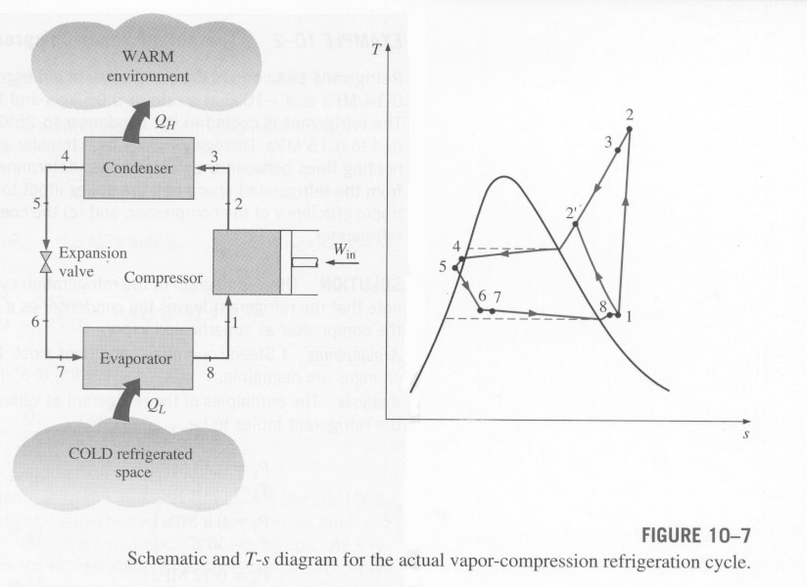
(Cengel, 2002)

4. Measure the relative humidity in the room, before the evaporator, after the evaporator, and after the reheater using the hand-held meter.

5. With the hand-held thermocouple reader, measure the air temperature at the inlet, before the evaporator, after the evaporator, and after the re-heater. Thermocouples do not measure temperature instantaneously. You must leave enough time for the thermocouple bead must come to the air temperature. Thirty seconds should be sufficient.

6. At the back of the apparatus, connect the thermocouple reader to ports A, B, and then C. A gives the refrigerant temperature at the exit of the condenser, B at the exit of the evaporator, and C at the exit of the expansion valve.

7. Use the rotameter to measure the refrigerant flow rate. Note the units which are listed on the side of the rotameter. Estimate how accurate your reading is.

8. Note the inclined manometer reading. This gives the pressure drop across the orifice plate. Estimate how accurately you can read the manometer. Warning: this manometer is not zeroed. When you have turned off the apparatus, measure the zero point, and subtract this value from the manometer to get actual pressure drop.

9. Stop the timer and measure the volume of the fluid collected. You can use the graduated cylinder to get a more accurate reading.

Task 2

- Starting with the First Law of Thermodynamics, derive the simplified version for each component in the simple vapor-compression cycle. Make a simple sketch for each component before doing the derivation.
- Using the following data, calculate the expected compressor power and the rate of heat added or lost in the evaporator and condenser. You don’t need to interpolate on the charts. Your TA will have several copies of the data charts.

R12 flow rate: 20 grams/s entering expansion valve: 45ºC, 990 kPa (gage)
entering evaporator: 10ºC exitting evaporator: 20 ºC, 322 kPa (gage)
exiting compressor: 80ºC

Task 3

- Calculate the rate of heat removed from the air in the evaporator using the following data. Check out the formula under “Calculations” number 2. Your TA will have several copies of psychrometric charts.

air entering evaporator: 30ºC, 50% relative humidity
air exiting evaporator: 14ºC, 100% relative humidity
condensed water: 4 ml over 25 minutes

- Calculate the mass flow rate of steam added to the air for the following situation. Check out the formula under “Calculations” number 4.

inlet air conditions: 20ºC, 35% relative humidity
after steam addition: 23ºC, 70% relative humidity
air mass flow rate: 0.1 kg/s

Calculations for Tasks 2 and 3 do not need to be turned in – only your final calculations.

Calculations

1. Calculate the heat input from the reheater from the measured temperatures. Use the first law.

How well does your calculated heat transfer rate compared to the 1 KW power listing of the reheater? What may be the cause of any differences? Remember to look at how accurate your temperature readings are (see the discussion on the green sheet) as well as your rough estimation of the uncertainty in air mass flow rate.

To calculate the mass flow rate of air, use the correlation below (it is specific to this particular orifice plate). Remember to subtract the zero point from your pressure drop!

kg/s

where the specific volume of air is in m³/kg and z in mm H₂0. Don’t worry about unit conversions – they’re all included in the “0.0504.”

2. Calculate the rate of cooling from the air data before and after the evaporator. Note that if there is condensation, you must take that into account with your calculations. You can estimate the temperature of the condensate as the temperature of the air leaving the evaporator.

Now calculate the rate of cooling using the refrigerant data. Note that we cannot calculate the enthalpy at the inlet to the evaporator directly. See the T-s diagram shown above. That point should be a liquid-vapor mixture, so we would need the quality which we cannot measure. However, we can assume that the enthalpy across the expansion valve is a constant.

Compare these two heating rates. Theoretically they should be equal. How close are they? What would account for any differences? Be as specific as possible when discussing sources of error. Estimate the magnitude of the error associated with different measurements

3. What is the saturation temperature for the low pressure? (Remember that gauge pressure is given, not absolute.) How does the measured refrigerant temperature at the evaporator exit compare? Is this logical based on the T-s diagram? If your pressure gauge read 20% higher than the actual pressure, what would be the effect on the value of h that you determined at the exit of the evaporator?

4. Calculate the rate of steam input from the relative humidity values. Remember that

where ω is the humidity ratio. You can use a psychrometric chart to find ω from the relative humidity and temperature values if you would like. Remember that ω should be much less than one – if yours isn’t, you have a problem. Do the measured relative humidity values change from position to position as you would expect? Why or why not? (Remember that the reader has an accuracy of +/- 2%.)

5. Calculate the mass flow rate of condensate from the humidity ratios before and after the evaporator as well. Compare this to the measured mass flow rate of condensate. What may cause any differences?

References
For review, basic equations, air tables, and psychrometric charts: Cengel, Yunus, 2002, Thermodynamics: An Engineering Approach, 4th ed., McGraw-Hill, New York (or any thermodynamics book)

For R12 charts , check out the class website.

