Thermal Resistance in a Computer Chassis
ME 146 Lab 2

Purpose
The goals of the lab are indicated below.
- Understand the effects of airflow impedance on air flow rates and system cooling
- Understand the effect of series and parallel fan configuration and when each configuration should be chosen
- Understand the effect of fan location on junction temperatures.
- Be able to use the thermal resistance method to predict junction temperatures

Background Theory and Apparatus

You already completed much of this lab during ME 114. However, it is an excellent review of the thermal resistance method, and we are adding some new pieces.

As you know, the junction temperature is of extreme importance for electronics. The higher the junction temperature, the lower the reliability of a system. Many electronics applications specify a maximum junction temperature of somewhere in the range of 60-120ºC. This specified temperature is not a strict cutoff, but rather the temperature above with the reliability of the component is no longer deemed satisfactory.

Unfortunately, we cannot directly measure the junction temperature without expensive and complicated electronics. For example, a special thermal diode is sometimes manufactured in a special test chip for the purpose of running experiments. In our case, a power resistor will be used to simulate the average heat dissipated by a Pentium 2 processor, which is around 12 Watts. The temperature of the resistor acts as the junction temperature of a real chip. Figure 1 shows where the resistor is placed with respect to the heat sink, casing, and printed circuit board.

In this case, heat is generated at the junction (resistor). Most of the heat travels up through the heat sink and convected to the air. However, some of the heat will be conducted through the PCB and convected to the air behind the PCB.

Four lab stations deliver information to a central computer which students will use to monitor the temperature of the resistors (T_{junction}), case temperature of the simulated CPU (T_{case}) and chassis air temperature (T_{ambient}). Each station is equipped with the following:

- 1- Computer chassis with variable impedance control
- 2- 1 ohm Power resistors --- generates approximately 12 W of heat at 5 V
- 1- Omega T-type flat self-adhesive thermocouple (# SA1 – T)
- 1- Omega T-type beaded thermocouple (# 5TC-TT-T-36-36) [BLUE]
or
1- Omega K-type beaded thermocouple (# 5TC-TT-K-36-36) [YELLOW]

In addition, the temperature of the board is measured using a thermocouple and can be displayed on the fan display on the back of the chassis. There are four fan configuration assemblies available for students to share. Each configuration is the same, so you and your group only need to work on one of them. The fans on the assemblies are Cooler Master SAF-B83 ball bearing fans.

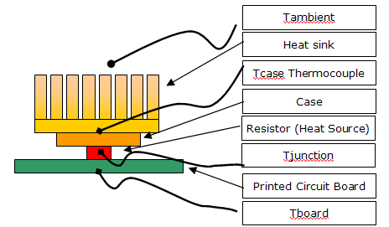
T_{b}
Θ_{jc}

Θ_{jb}

Θ_{ca}
T_{junction}
T_{case}
T_{ambient}
Θ_{ba}

T_{ambient}

Figure 1. Illustration of components used to simulate heat of a CPU. This illustration is not to scale. In actuality the resistor and case are thin, so you can assume 1-D heat conduction to simplify calculations.

Procedure

The second part of this lab involves collecting data for different fan configurations and system impedances. Each lab station will run a series of five different tests; each test will roughly be 15-20 minutes long or until steady state has been reached. Do not record data until it is clear that steady state has been reached for a given configuration. To verify that this is true, check to be sure that temperatures have changed only a negligible value over a several minute period.

Choose one of the lab stations. It does not matter which one you pick, except do not use Station 4, which is having issues. 1. Turn on your computer setup. You initially will hear a warning beep to signify that the original computer fans are not turned on. Press the button of the Aerogate II to turn off the warning beep.

Notes on Lab station number 4: In order to initially run station lab station four, the external ground and fans must be disconnected. The external ground can be disconnected by disconnecting the black clip from the wire near where the fans are disconnected. Turn on the lab station taking care to ensure that the power supply is running. If the power supply turns off, turn your station off and disconnect the power cord. Reconnect the power cord and turn it on. Once the power supply is running, reconnect the fans to the appropriate fan power supplies, as well as the ground to the ground connection. Measure the voltage across the voltage probe as indicated in the above section. If there is no voltage measured, disconnect the ground from the ground connection, and then reconnect. There should be a measurable voltage of about 5 volts.

2. You will be running five different fan/impedance configurations. See the table below. To change fans, carefully disconnect your fan setup by disconnecting the power line for each one. Your TA can show you how to do this. Then carefully pull the fan configuration out. Replace it with the other fan configuration. Reconnect the power lines – make sure that you’re connecting them to the power cords, which are labeled. For the natural convection case, just disconnect the power lines to the fan. It’s best to do the natural convection case last. For the others, the order doesn’t matter.

For the high impedance case, close the slot in the front of the chassis. For the low impedance case, open it.

3. Your instructor will have the computerized data acquisition system already booted up (filename: Airflow Impedance Lab V2.vi). This system will tell you T_{junction}, T_{case}, and T_{ambient}. Use the Aerogate II on the front of the computer to measure the board temperature. The sticker on the front of the computer will tell you how to do that. Remember to wait for steady state to occur before recording temperatures. If you use System #3, you will measure the temperatures using a handheld reader instead of the data acquisition system.

To measure the voltage across the resistor, use a multimeter to probe the two terminals near the wiring exiting the system (Figure 2). {The voltmeter should be set on auto (button on far right), and you’re looking for dc voltage.} This is the orange plastic device duct-taped to the back of the computer. Remember V/R = I and P = I²*R.
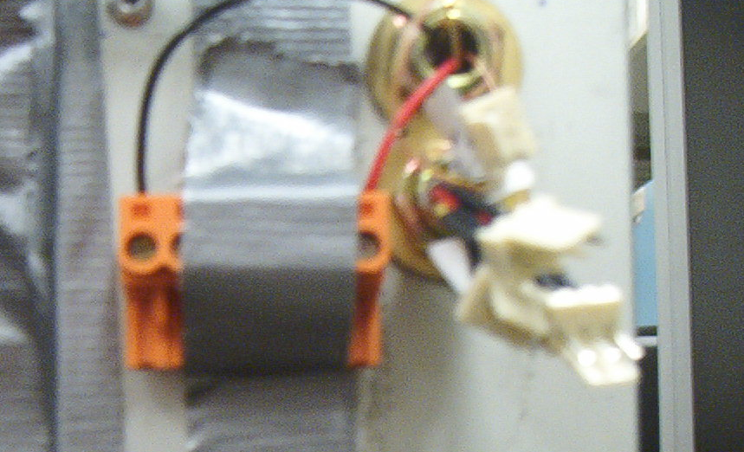
Figure 2. Probe two outside terminals to measure voltage across resistors.

On the data acquisition system, you should have the on/off and ground reference buttons on (they will be bright green). Here are the channel numbers for the thermocouples.
Station 1: junction (4) case (9) ambient (3)
Station 2: junction (8) case (6) ambient (7)
Station 3: Use a handheld thermocouple reader instead.
Station 4: junction (13) case (12) ambient (14) – unused during this lab

To start the data acquisition system, click on the button on the top left of the toolbar that looks like two arrows in a circle.

While each test is running students are encouraged to complete calculations, described below, that will assist with writing the report.

Date
Station No.
Heatsink Description
 | Test Run Time | Chassis Temp  (T_{Amb}) | Case Temp  (T_{Case}) | Junction Temp  (T_{Junction}) | Board Temp  (T_{board}) | Voltage Across Resistor
Test 1.
Parallel fans with high impedance
Test 2.
Parallel fans with low impedance
Test 3.
Series fans with high impedance
Test 4.
Series fans with low impedance
Test 5.
Natural Convection
(Fans off)

4. Now go to lab station number 3. Your professor will replace the fan configuration with a fan attached directly to the heat sink. Measure the junction temperature for this situation.

5. Now your professor will remove the heat sink. Watch how quickly the chip temperature rises without the heat sink! We will not let the chip come to steady state or the circuits may fry.
Calculations and Analysis
1) Calculate the rate of heat generated for each case under Section 3, assuming a 2 ohm power resistor.

2) Assuming no heat loss through the PCB, calculate the thermal resistance from the junction-to-case and case-to-ambient for each situation.

3) Now estimate the percentage of heat that is lost through the PCB.
- First do this calculation assuming that you hadn’t measured the board temperature. This calculation will require you to make a lot of assumptions. Do this for one of your forced convection cases.
- Now calculate this percentage using the measured board temperature. How close are your two numbers? What do you think are the largest causes of any discrepancy?

4) Re-calculate the thermal resistance from the junction-to-case and case-to-ambient for each situation using your answer from #3.
- Should the junction-to-case thermal resistance vary significantly from situation to situation? Why or why not?
- How does the thermal resistance from the case-to-ambient vary from situation to situation? Is it significant? Does it make sense with the airflow data? If the results don’t act like you expect, what causes the differences?

5) Now using an estimate of the contact resistance, calculate the heat sink resistance for the low impedance, series resistance case. Compare this resistance to ones found for similar heat sinks found on a manufacturer’s website. Do your numbers seem reasonable?

6) The fan that was attached directly to the heat sink had a lower CFM than the original fans, yet it most likely resulted in a lower junction temperature. Why? Why might it still be good to place a fan directly in the chassis frame? What does this lower temperature tell us about the importance of fan location? How could we keep the fans located in the chassis frame but still improve the flow rate through our heat sink?

