Heat Sink Performance Testing

Introduction:

The heat sink is a very important component in cooling design. It increases the component surface area significantly while usually increasing the heat transfer coefficient as well. Thus, the total resistance from the component junction to the surroundings is reduced significantly, which in turn reduces the junction temperature within a device. As a result, obtaining correct performance characteristics for heat sinks is extremely important in cooling design solution.

The objectives of these experiments are to evaluate the performance of heat sinks, determine the effect of flow velocity, and to analyze results by comparing them to published correlations.

Theory:

A heat sink works by conducting heat through its base and fins and then convecting it to the surroundings. The equation for thermal resistance of a heat sink is shown in Equation (1)
T_{base} - T_{air}
R_{HS} = ----------------- (1)
Power
The thermal resistance can be found from experimental testing, simulation, or manufacturer’s data. In this lab, you will be using Equation (1) to find heat sink resistance and comparing results to published correlations.

The heat sink resistance includes both the conduction and convection resistance, although the convection resistance typically dominates. Equation (2) is a somewhat simplified equation for the heat sink resistance. This equation would be completely accurate if conduction and convection were in parallel. However, this is not completely the case for heat sinks, so this equation incorporates some inaccuracies.

1
R_{HS} = ----------------------------------- (2)
1/R_{conduction} + 1/R_{convection}

Conduction resistance can be lowered by changing the geometry and choosing a material with a higher thermal conductivity. Convection resistance can be lowered by increasing the heat sink surface area or the heat transfer coefficient. The heat transfer coefficient will change with both geometry and flow velocity for a given fluid type.

More commonly, heat sink resistance is found using the equation for fin resistance given below.

R_{fin} = 1/ hη_{f}A_{fin} (3)

Here η_{f}, the fin efficiency, takes into account the conduction resistance and is equal to the actual fin heat transfer divided by the fin heat transfer if it were to have been all at the heat sink base temperature. The heat sink resistance becomes

R_{HS} = 1/ hη_{o}A_{tot} (4)

where

η_{o}=1-NA_{fin}(1-η_{f})/A_{tot} (5)

Here η_{o} is the overall surface efficiency, N the number of fins, and A_{tot} the total heat sink surface area.

The correlations with which you will be comparing your experimental results are given in Appendix A.

Apparatus:

A wind tunnel and test fixture were designed to evaluate the heat sinks. In some testing apparatuses, some fluid bypasses over the top or around the sides of the heat sink. This problem is eliminated here by making the flow channel the same size as the heat sinks to be tested. A somewhat fuzzy photo of the setup is shown in Figure 1. To induce fluid flow, a 6 inch electronics cooling fan in “pull” configuration is used. The fan operates from 14V to 30V on DC current. To measure fluid flow, an orifice plate with a diameter of 0.5 inches is used in the center of the wind tunnel. Pressure taps upstream and downstream of the orifice plate measure the differential pressure. Using this differential pressure, it is possible to measure fluid flow rate. There is also a pressure tab directly behind the heat sink to measure the pressure drop across the heat sink. However, in this lab it will not be used.

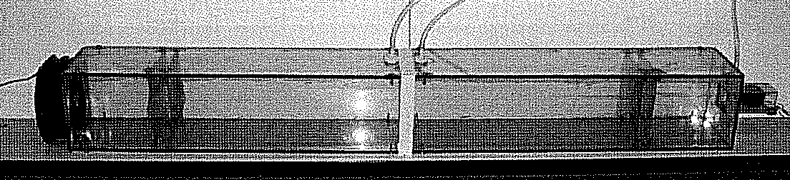

Figure 1. Wind Tunnel

If your instructor has not already set up the apparatus, you will need to do so. First, tape the two sections of the wind tunnel together with the orifice plate in the center. The tape should go all the way around the wind tunnel to prevent leaks. The screens in the wind tunnel help induce and spread straight flow. The pressure taps before and after the orifice plate must be connected to the 0-1” inclined manometer using vinyl tubing. At the end of the wind tunnel, the axial fan is attached using tape. While attaching the fan, direction of the rotation of blade and air flow direction are important. Rotation of the fan blades should be in anti-clockwise direction when facing to the fan. The direction of the air flow should be in pull direction. Use tape to attach the fan. Some small leaks are acceptable in this location. Connect the fan leads to the positive and negative power supply terminals of the large DC power supply.

On the front end of the wind tunnel, there is a small square duct test section where the heat sink units are placed. There are four heat sink units to be tested, and they can be inserted one at a time into the square duct for testing. The bottom part of each heat sink unit has a special lip to easily clip onto the bottom plate of the square duct. Since the design of the clip is shaped like a hook, the heat sink tray should not move during testing. See Figure 2 for an example. On the top of the base of each heat sink unit is a polycarbonate sheet which has a very low thermal conductivity. It is used as an insulator to ensure that most of the heat generated goes up through the heat sink. On the top of the polycarbonate sheet is the heating pad, and on the top of the heating pad is the heat sink with high thermal conductivity. Thermal tape with a high conductivity is used to connect the heating pad to the heat sink with only a small contact resistance. Thermocouples are placed on the top and bottom of the polycarbonate pads to measure the temperature difference across the piece.

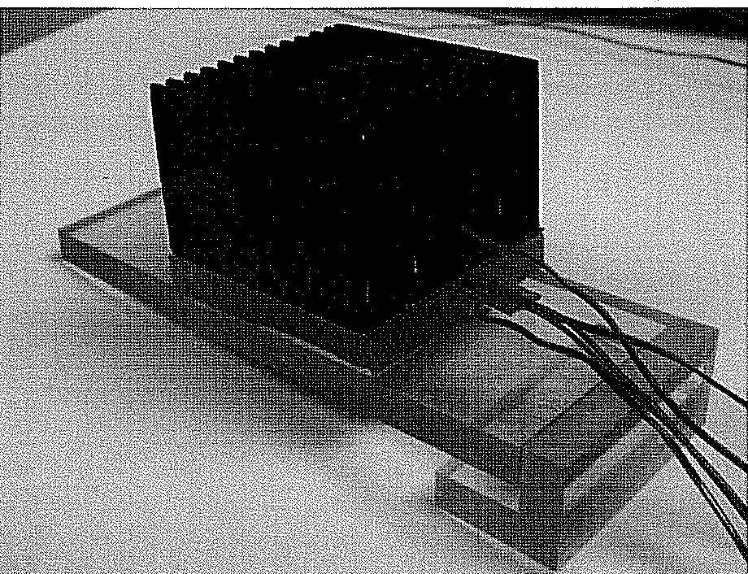

Figure 2 Heat Sink Unit

Figure 3 shows how to hook up the power for the heater pad to the second DC power supply.

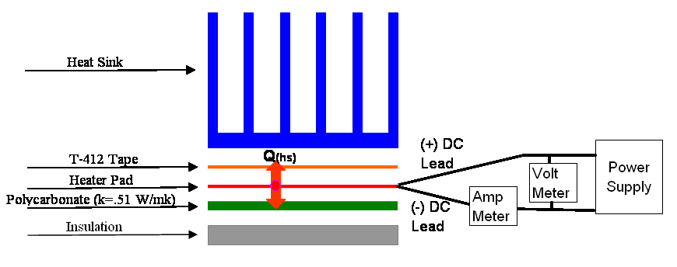
Figure 3 Power Attachment for Heater Pad

To adjust the power going into the heat pad, one must read off the current and the voltage being supplied by the power supply. Power = Volt x Current (Watts)

Different heat sinks are used to evaluate the performance. Two are straight-fin heat sinks with different fin counts (6 and 13 fins), one is a pin fin heat sink with 49 pins, and one an elliptical pin fin heat sink. All the heat sinks had the same base cross sectional area of 1.5” by 1.5”. Heat sink dimensions are given in Appendix B.

T type thermocouples are used with a handheld thermocouple reader to measure temperatures. T type thermocouples have a sensitivity of 0.5 ⁰C at 300K although use of a handheld reader reduces accuracy to roughly +/- 2°C. Four thermocouples are used in each set up. One should be placed in the flow of the inlet air to measure the temperature of the ambient air. A small hole is drilled into the middle of the heat sink base and a thermocouple is placed inside of it to measure the base temperature of the heat sink. One thermocouple each is placed on the top and bottom of the polycarbonate insulator.

Procedure:

For each heat sink, take data for eight different flow speeds, ranging from 300 – 500 LFM (linear feet per minute), which is a typical range of application. An equation to give approach velocity at a given orifice differential pressure is
LFM = -164.36(ODP)² + 549.99 ODP + 152.2 (6)

where LFM is linear feet per second and ODP is orifice differential pressure in inches of water. Thus, the fan should provide an orifice pressure drop of about 0.3 to 0.85 inches of H₂O. To achieve these pressure drops, turn up the current output a maximum of approximately 3 amps. Then adjust the voltage between 13 and 30 volts to control flow speed. Make sure that you zero the manometer before starting the first test.

The heat sink resistance should not be a function of the power supplied in the heater pad. The power supplied is chosen to achieve a large enough temperature difference to minimize inaccuracies of results while at the same time not burning out the heater pad. Once chosen, the heater power should not be changed during the tests for a given heat sink. Use the following approximate input parameters for each heat sink:

6 Fin Straight Fin Heat Sink: 22.3 V, 0.75 A
13 Fin Straight Fin Heat Sink: 37.1 V, 0.46 A
Pin Fin Heat Sink: 27.0 V, 0.63 A
Elliptical Fin Heat Sink: 21.7 V, 0.77 A

For each heat sink, fill in the table below. Make sure that steady state has been achieved before recording data.

Experimental data:

6 fin heat straight heat sink experimental data.

Run No. | Differential pressure (in H₂O) | Heater Voltage (V) | Heater Current (A) | Ambient temp  (⁰C) | HS base temp (⁰C) | Top of polycarbonate temp. (⁰C) | Bottom of polycarbonate temp. (⁰C)
1
2
3
4
5
6
7
8

13 fin heat straight heat sink experimental data.

Run No. | Differential pressure (in H₂O) | Heater Voltage (V) | Heater Current (A) | Ambient temp  (⁰C) | HS base temp (⁰C) | Top of polycarbonate temp. (⁰C) | Bottom of polycarbonate temp. (⁰C)
1
2
3
4
5
6
7
8

Pin fin heat straight heat sink experimental data

Run No. | Differential pressure (in H₂O) | Heater Voltage (V) | Heater Current (A) | Ambient temp  (⁰C) | HS base temp (⁰C) | Top of polycarbonate temp. (⁰C) | Bottom of polycarbonate temp. (⁰C)
1
2
3
4
5
6
7
8

Elliptical fin heat straight heat sink experimental data

Run No. | Differential pressure (in H₂O) | Heater Voltage (V) | Heater Current (A) | Ambient temp  (⁰C) | HS base temp (⁰C) | Top of polycarbonate temp. (⁰C) | Bottom of polycarbonate temp. (⁰C)
1
2
3
4
5
6
7
8

Calculations:

1. To calculate the heat traveling to the heat sink, use the following equations:

Input Power: $Q_{\text{total}}=\text{Voltage}×\text{Current}$
Power Lost (to bottom of test heat sink): $Q_{\text{loss}}=\frac{\text{KA}(T_{\text{polycarb}\text{.}\text{top}}−T_{\text{polycarb}\text{.}\text{bottom}})}{L}$
K of the polycarbonate block is 0.51 W/mºC and the thickness of the block was measured to be 5.89 mm. The area of the section is the same area with all the base heat sink areas: 1.45e⁻³ m².

Power going to heat sink: $Q_{\text{HS}}=Q_{\text{total}}−Q_{\text{loss}}$

2. Equation (6) can be used to calculate the inlet fluid velocity for each situation.

3. Calculate the heat sink thermal resistance for each test using Equation (1).

4. For the two straight fin heat sinks and the pin fin heat sink, also calculate the expected thermal resistance from the correlations given in the appendix for each test.

Results/Discussion

1. Plot heat sink resistance vs. LFM for each heat sink on four separate graphs. Both experimental and expected heat sink performance (from the correlations) should be included, except for the elliptical fins for which you only have experimental results.

2. How does heat sink resistance change with LFM? Why?

3. Plot experimental heat sink resistance vs. LFM for the two straight fin heat sinks on the same graph. How do the results compare? Explain why from a technical heat transfer perspective.

4. Calculate the uncertainty in your results from the temperature uncertainty alone, assuming each reading has an uncertainty of +/-2°C.

5. How well do the experimental and expected results compare? What are the main causes of any differences? Note that the correlations also have an uncertainty of at least +/- 10%.

6. Compare your straight fin, pin fin, and elliptical fin results. Why is a strict comparison among these types of heat sinks difficult using only your data?

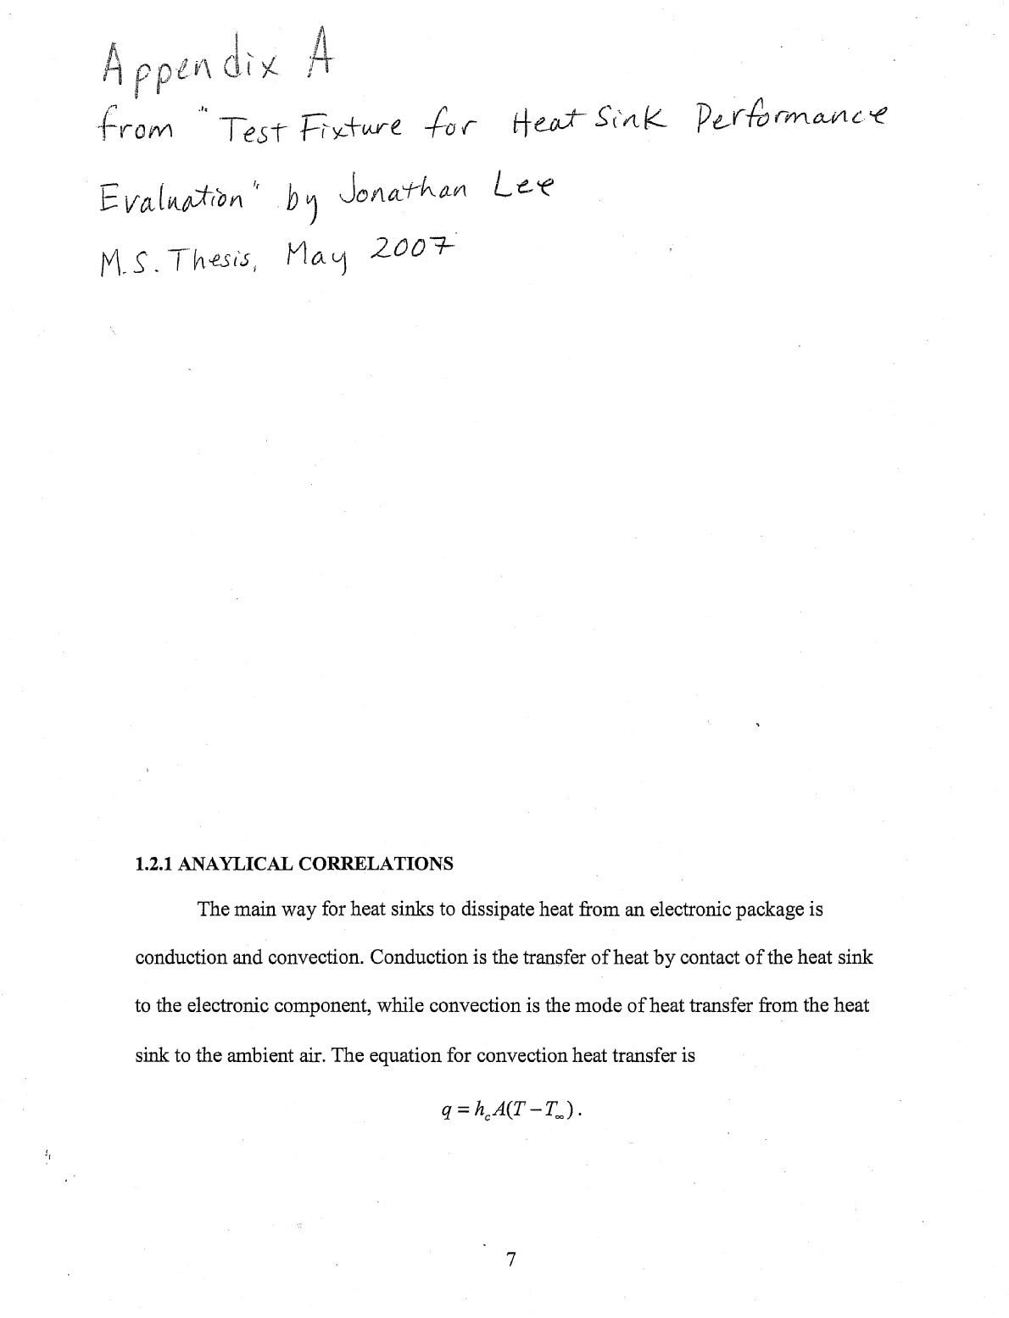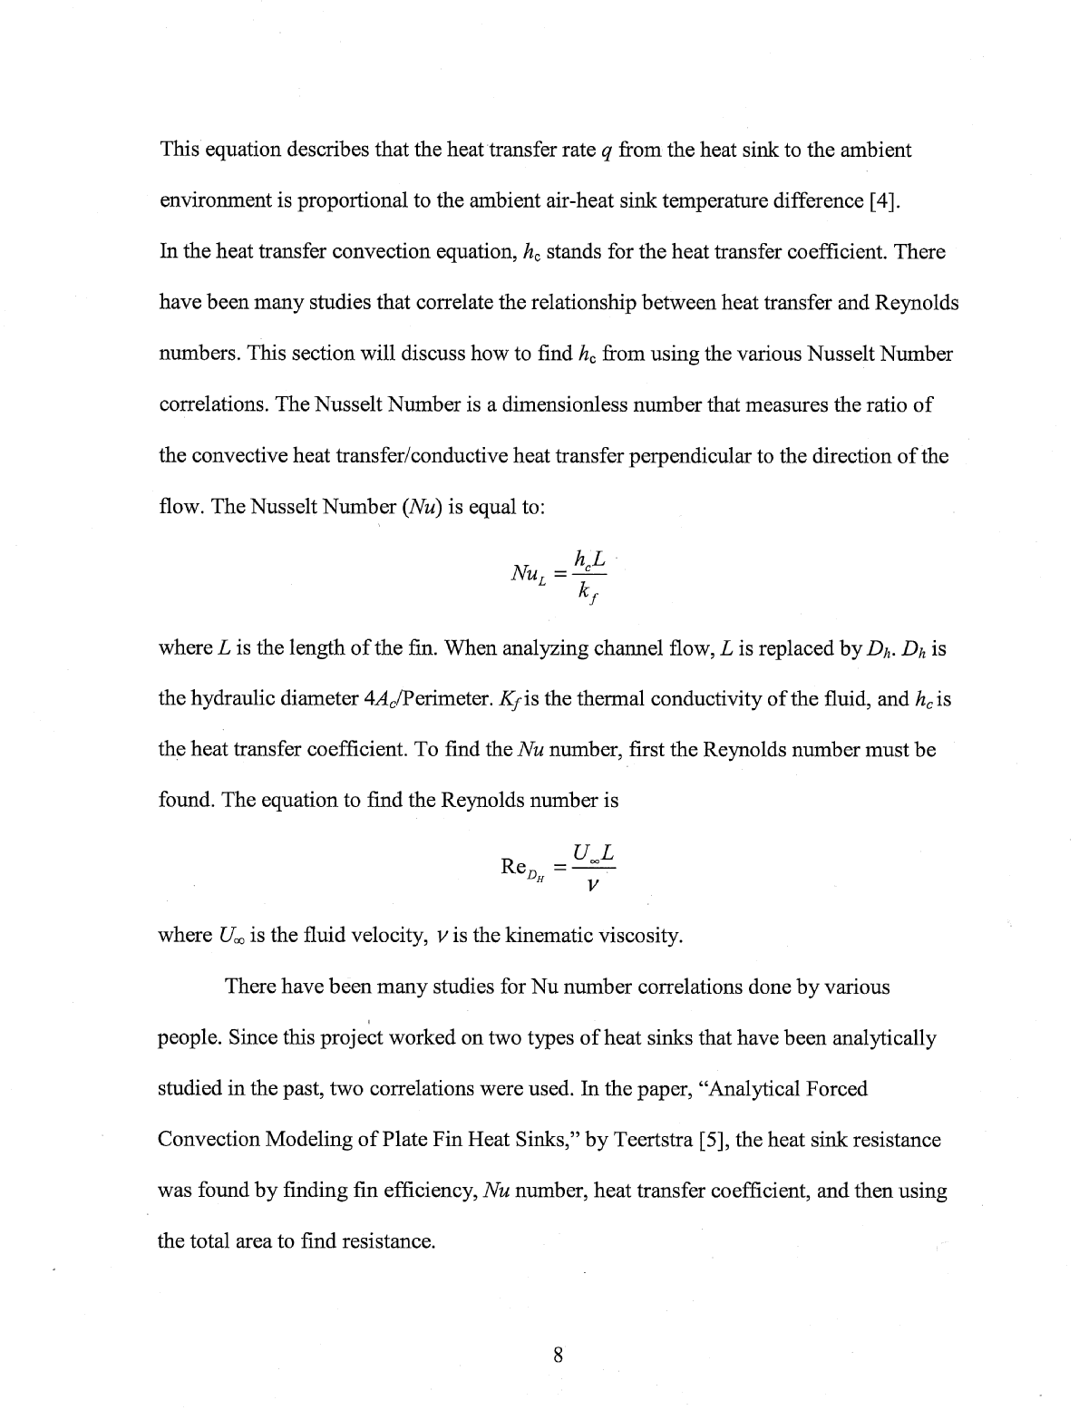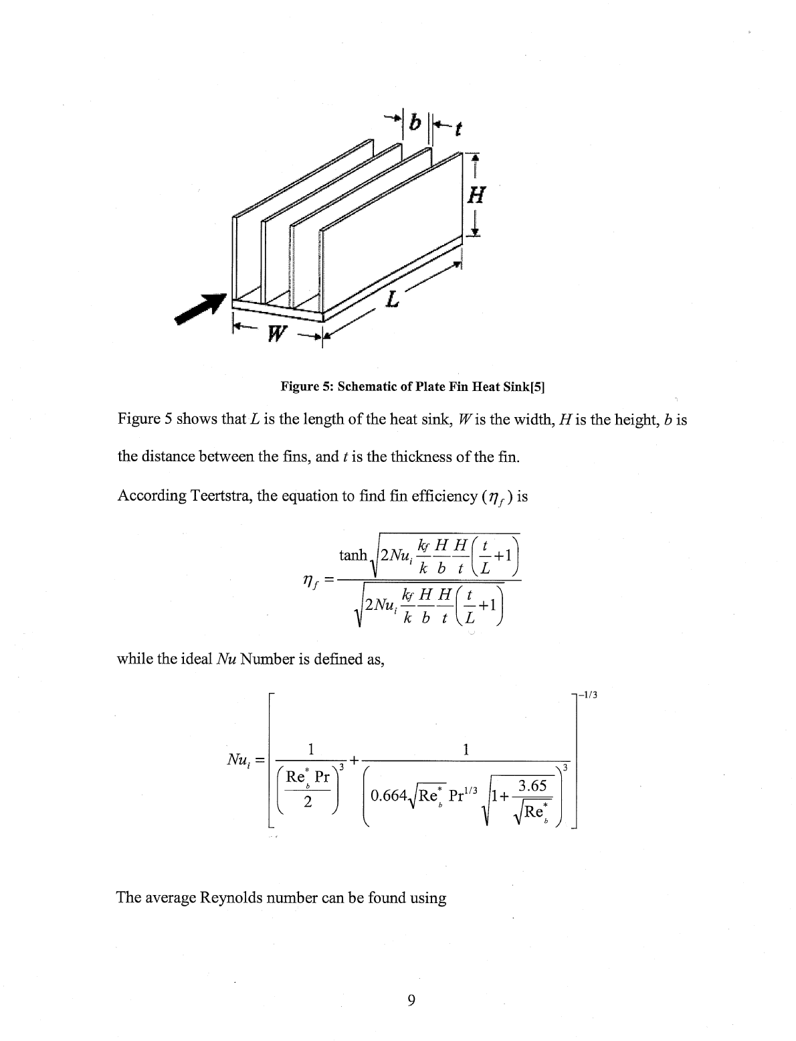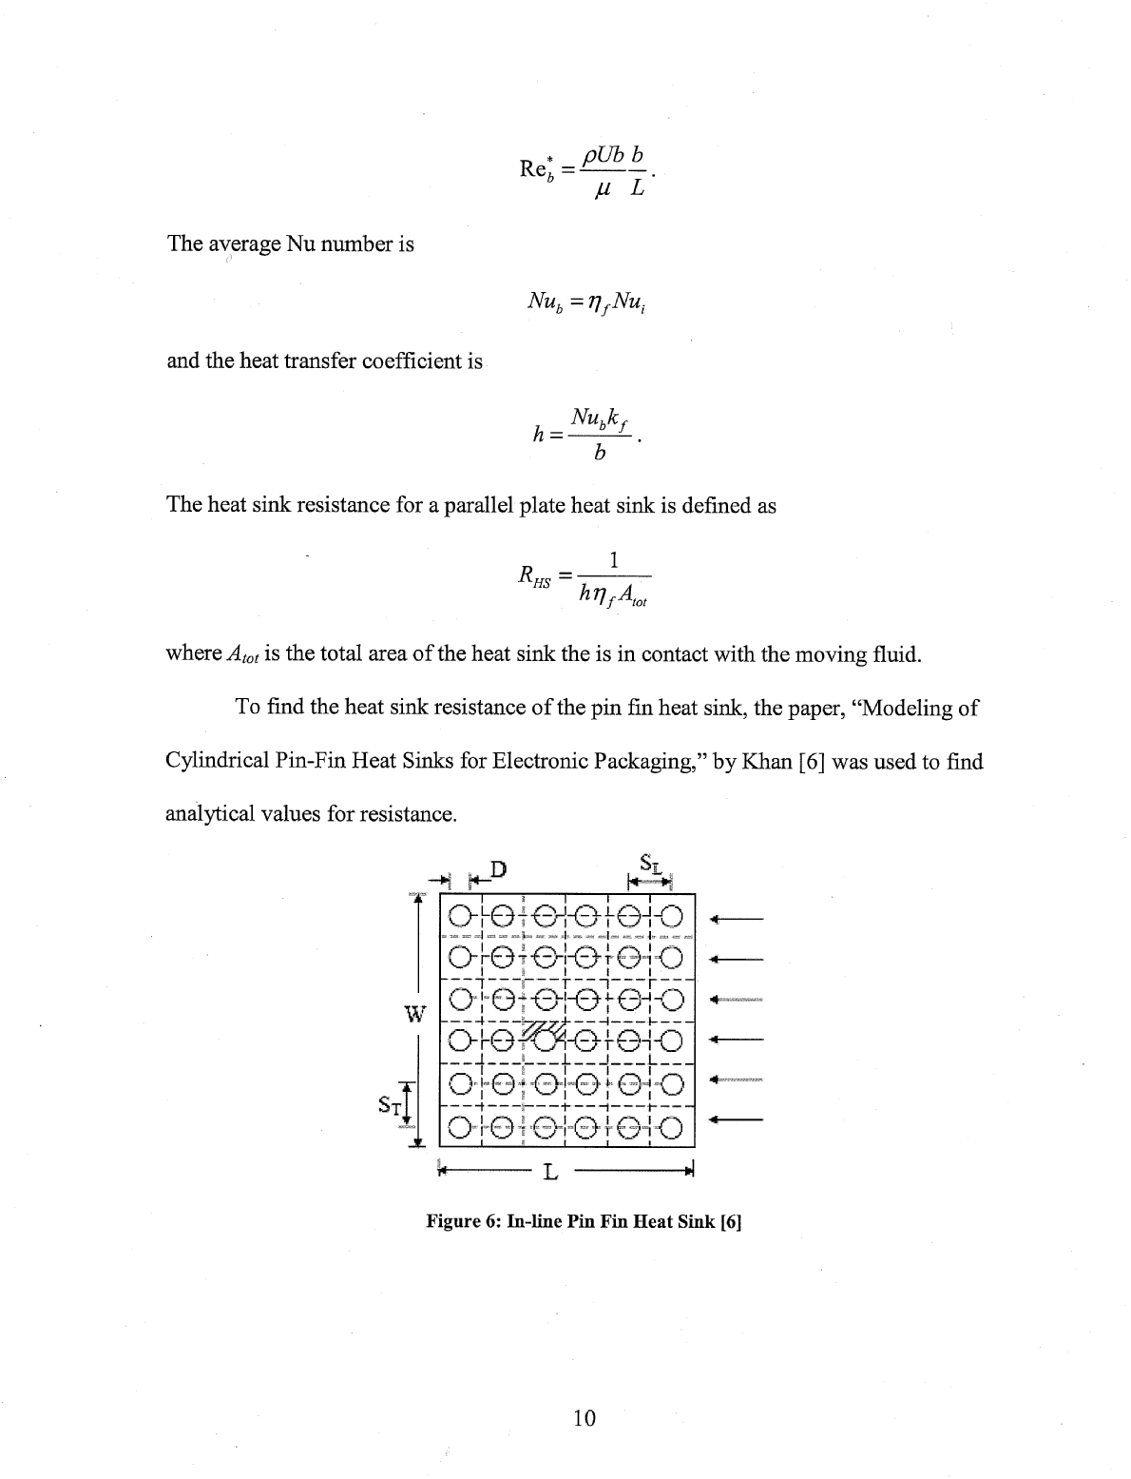

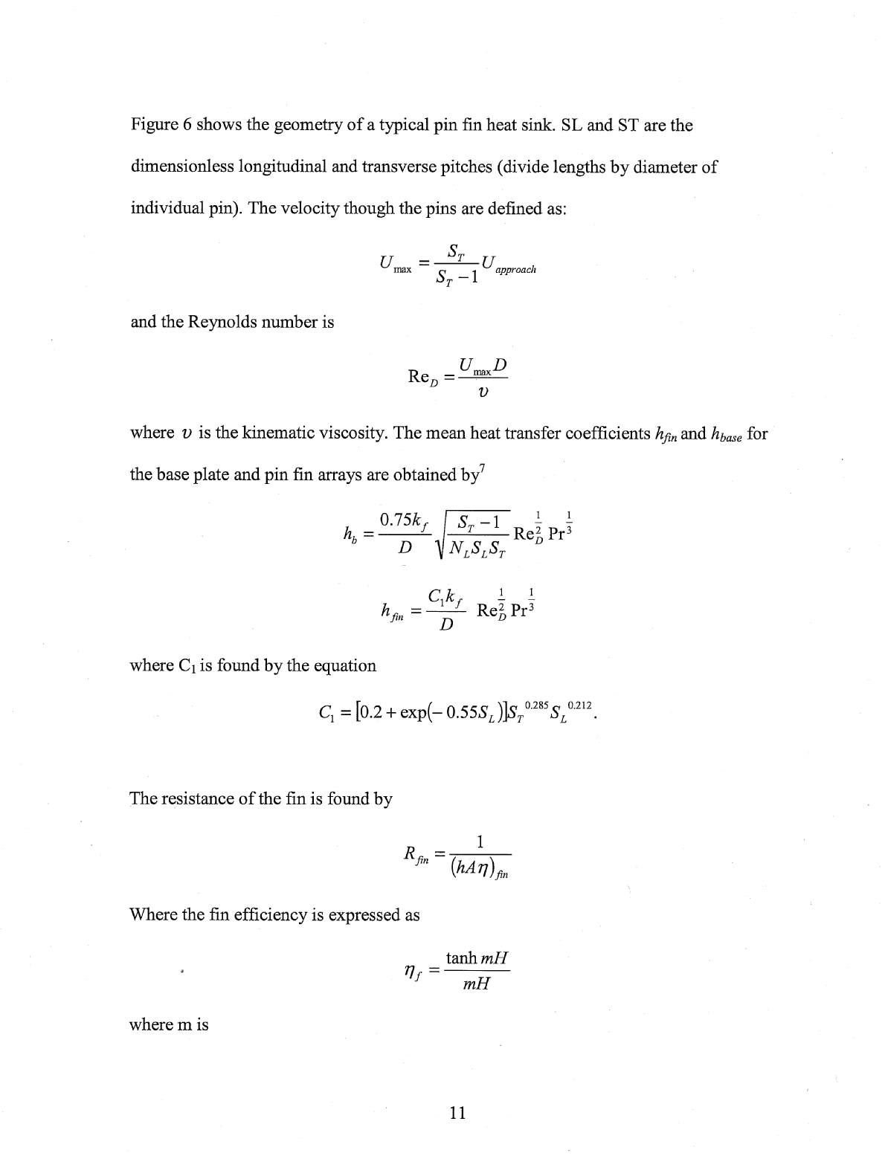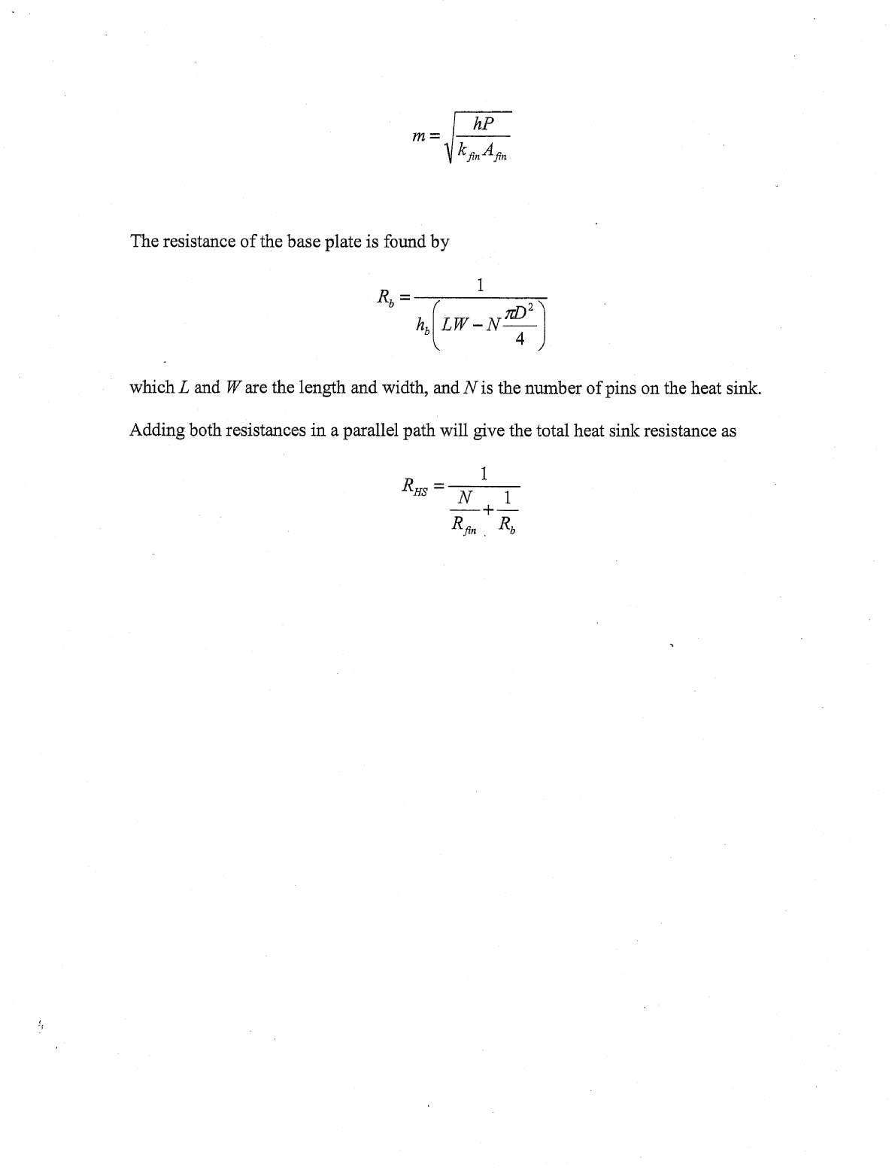

Appendix B Heat Sink Geometry Data

For all heat sinks, base width and length are 1.5”, and total heat sink height (base + fins) is 1”. In the text of Appendix A, note that k_{f} is the thermal conductivity of the fluid, and k and k_{fin} are the thermal conductivities of the metal (aluminum).

Straight fin heat sinks
parameter | 6 fin heat sink | 12 fin heat sink
t (m) | 1.0e-3 | 8.33e-4
b (m) | 6.5e-3 | 2.26e-3
H (m) | 2.4e-2 | 2.27e-2

Pin fin heat sink

parameter
D (m) | 1.50e-3
SL (dimensionless) | 3.47
ST (dimensionless) | 3.47
N (dimensionless) | 49
fin height (m) | 2.00e-2

