Geology 3
Plate tectonics and plate boundaries
Examine the map below.
- Color the North American Plate and the Pacific Plate.
- Label the San Andreas Fault.
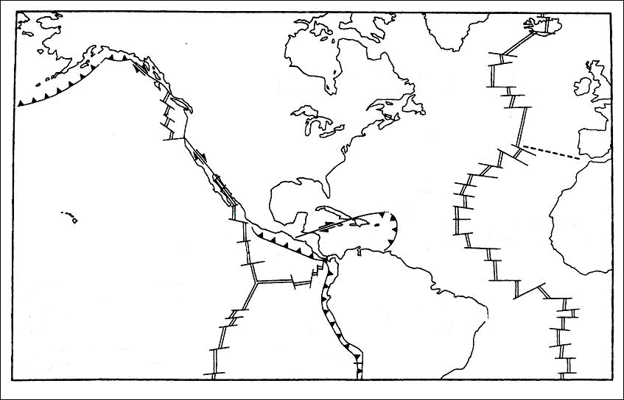
- The North American plate contains what type of crust(s)?
- There are three symbols on the map that represent the three plate boundaries. Sketch the symbols below:
  - Divergent plate boundary:

  - Convergent plate boundary:

  - Transform plate boundary

- What is the direction of plate movement at each boundary?
  - Divergent plate boundary:

  - Convergent plate boundary:

  - Transform plate boundary

- The eastern boundary of the North American plate is a ________________ boundary.
- What process occurs at this plate boundary that produces oceanic crust.

- The western boundary of the North American plate contains what type of boundaries?

- In your own words, explain the tectonic map of Japan below.

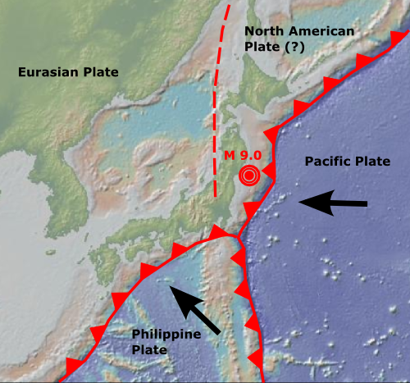
- Sketch a cross-section of the plate boundary where the Pacific plate meets the North American plate.

