DNA COMPUTING

Usha Narra
Computer Science Department
San Jose State University
San Jose, CA 95192
408-924-1000
Email: usha.narra@sjsu.edu

ABSTRACT

Discovery of Integrated circuits (microchip or simply ‘chip’) have revolutionized the world of electronics. Today, Integrated circuits are used in almost all electronic devices that we use. The basic building block of these microchips is Silicon. However, advancements in technology have given rise to an interdisciplinary area which uses DNA instead of Silicon to perform computations and store data. This new technology is known as “DNA Computing”. Though DNA computing is still in its infancy stage, researchers believe that one day DNA might be integrated on to a microchip to create the so-called ‘bio-chip’ which will make computers even more faster and energy efficient. This term paper is organized as following sections:
- Introduction
- What is DNA Computing?
- Advantages
- Limitations
- Conclusion

INTRODUCTION

Why DNA Computing?
Silicon is the second most abundant element in the Earth’s crust next to oxygen. The abundance and semiconductor properties have made Silicon the ideal element in the manufacture of computer chips for more than 50 years. Over these 50 years manufacturers have been successful in making silicon-based chips smaller, more complex and faster than their predecessors. However, there is a limitation to how small, compact and fast the silicon computer chips can be. According to Moore’s law [3], the number of transistors on a chip double every 18 months. The law is named after Gordon E. Moore, co-founder of the Intel Corporation, who described the trend in his 1965 paper. Moore’s prediction has proven to be accurate so far. If the current trend continues to 2020, the number of transistors on a chip would reach 32 billion (Figure 1).
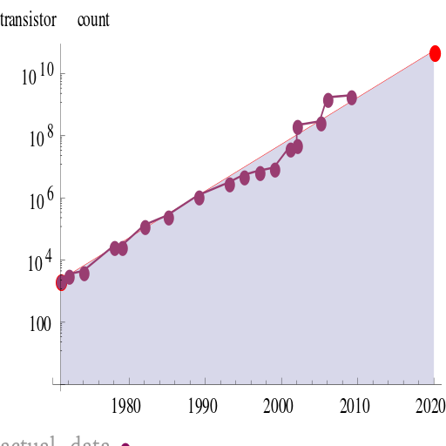
Figure 1: Moore’s law graph

Moore’s law is now used in the semiconductor industry to guide long-term planning and to set targets for research and development. In today’s integrated circuits, the size of transistor is at 22 nanometers and at this rate, it can be expected to reach the size of 5 nanometers by 2020 which is practically impossible to achieve since the wavelength of an electron in Silicon is 5 nanometers. Microprocessors made of silicon will eventually reach their limits of speed and miniaturization. Chip manufacturers need a new material to produce faster computing speeds. Futurist, Ray Kurzweil speculates that it is likely that some new type of technology (e.g. DNA computers, Optical computers, Quantum computers) will replace current integrated-circuit technology, and that Moore's Law will hold true long after 2020. In this paper we will see how and why DNA computing could be a promising field. Before diving into DNA computing, we first need to understand some terms and biological concepts that we encounter in DNA computing. Section 1.2 gives an insight into some related biological terms and concepts.

What is DNA?
DNA (Deoxyribonucleic acid) is a molecule that contains genetic information of all the living organisms on Earth. Each DNA molecule is a linear strand containing sequences of four bases or nucleotides namely Guanine (G), Adenine (A), Thymine (T) and Cytosine (C). The single strands of DNA pair up length wise in anti-parallel fashion to form a double strand. This double strand resembles the shape of a twisted ladder or a double helix (Figure 2). The process of combining two single strands into a double strand is known as ‘Annealing’. Similarly a process known as ‘Denaturing’ allows the double helix to separate into two single strands when heated to a certain temperature.
Now let us see some biological properties of DNA which later prove to be useful for DNA computation. The twisted double helix structure gives DNA the power to pass along biological instructions with great precision. Among the four bases present in the DNA molecule, Adenine on one strand of the helix pairs up with Thymine on the other strand. Similarly Cytosine on one strand pairs with Guanine on the other strand. This is known as base pairing. The complementary nature of this base-paired structure provides a backup of all genetic information encoded within double-stranded DNA, i.e., a living organism’s biological information is encoded in these DNA strands. In other words DNA stores the organism’s biological information just as a hard drive stores information on a computer. Several enzymes act on DNA to alter its structure and/or behavior. One such enzyme is ‘Ligase’ which acts as a catalyst in joining two complementary fragments of DNA and in repairing single stranded breaks that arise during replication. Enzymes called ‘Restriction enzymes’ are used to cut the DNA strands at or near some specific subsequences. Another important enzyme that is useful in DNA computation is ‘Polymerase’ which extends certain sequences of DNA strands by making copies of it.
The unique material properties of DNA have made it an attractive molecule for scientists and engineers. This gave rise to the questions, Can DNA be used to store any other information? Can DNA be used for any other purpose other than just storing information? Etc. We will find answers to these questions in the following sections.

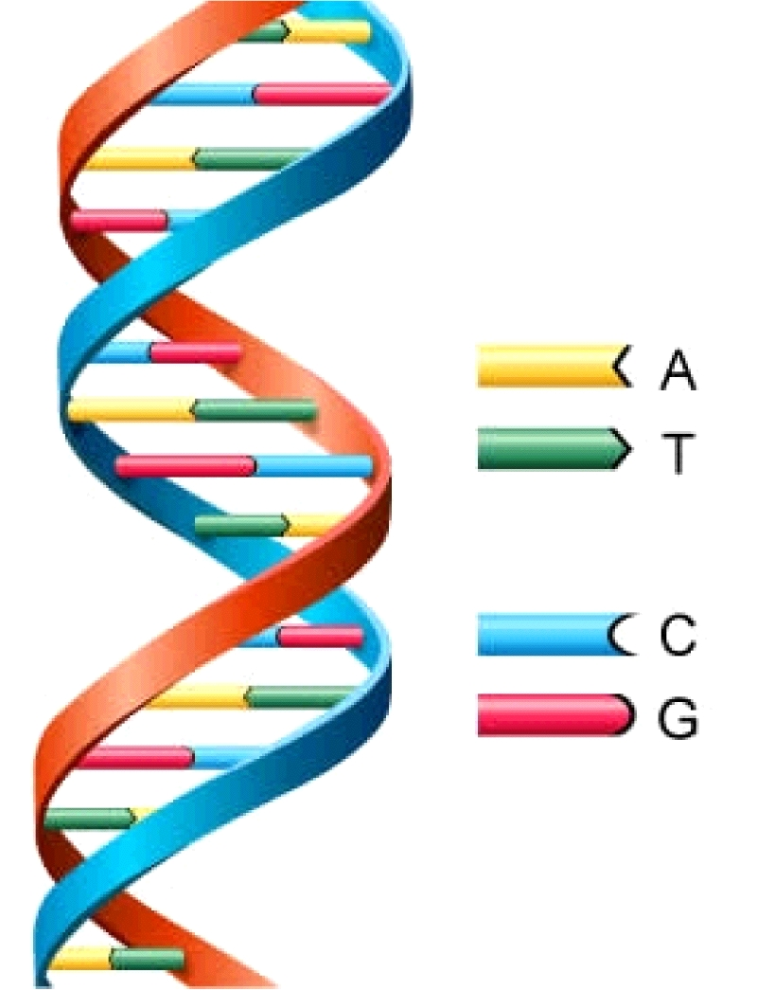
Figure 2. Structure of DNA double helix

What is DNA Computing?
So far we are using silicon based computer technologies where the basic building blocks of computation are silicon microchips. But the unique properties of DNA are giving rise to a new computing technique known as ‘DNA Computing’, where the basic building blocks are DNA strands instead of traditional silicon-based microchips [1]. DNA computers will work through the use of DNA-based logic gates. These logic gates are very much similar to what is used in our computers today with the only difference being the composition of the input and output signals. In the current technology of logic gates, binary codes from the silicon transistors are converted into instructions that can be carried out by the computer. DNA computers, on the other hand, use DNA codes in place of electrical signals as inputs to the DNA logic gates. DNA logic gates are the first step toward creating a DNA computer that has a structure similar to that of an electronic computer. The DNA logic gates detect fragments of genetic material as input, splice together these fragments by chemically binding them and form a single output.
Even though the idea of using molecules for computation dates back to late 1950’s, DNA computing did not gain much attention until early 1990’s. Leonard Adleman, professor and computer scientist at the University of Southern California is the first man to demonstrate the use of DNA as a form of computation. Adleman actually used DNA to solve the seven point Hamiltonian path problem (a variant of the travelling salesman problem) and proved that DNA has computational power. Since then many other scientists/researchers have worked on studying theoretical and practical models of DNA computing. Adleman is often called as ‘Father of DNA Computing’.

Hamiltonian Path Problem
In the Hamiltonian Path Problem, the aim is to find the shortest route between the given cities, going through each city only once. The basic idea of Adleman’s experiment is as follows:
- Encode DNA strands with A, T G and C such that some sequence of these bases uniquely represents each of the seven cities.
- Mix the DNA molecules in a test tube. The base pairing capability of the DNA strands allows them to stick/pair with each other. A chain of these paired strand represents a possible answer.
- All possible solutions for the given problem are created in the test tube.
- Eliminate the wrong combinations and arrive at the correct solution.
In his experiment, Adleman used seven cities to solve the Hamiltonian Path Problem. Let us consider a simple example of five cities and see how DNA can be used to solve this problem [2].
Let the five cities that we want to travel are Los Angeles (LA), Chicago, Dallas, Miami and New York (NY) with LA as the starting point and NY as the destination. The arrows as shown in Figure 3 represent the connecting route between the cities.

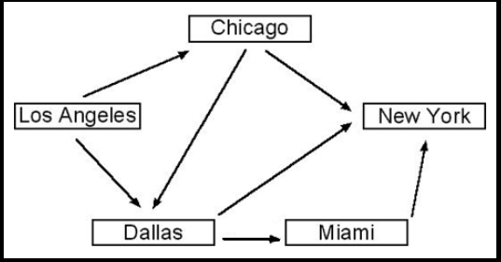
Figure 3: Cities and connecting routes

First step is to encode the cities as unique DNA sequences. Let each city be represented by a DNA strand of six bases as shown in Table 1.

Table 1. City Encodings
City | Encoding
Los Angeles | GCTACG
Chicago | CTAGTA
Dallas | TCGTAC
Miami | CTACGG
New York | ATGCCG

The encoded itinerary between the cities is obtained by linking the corresponding city encodings in proper order. This linking is made easy with DNA’s ability to hybridize with its complimentary sequence. So route encoding between two cities can be done by linking the compliment of last three letters of departure city and first three letters of arrival city. For example, to get the encoded route between Miami (CTACGG) and NY (ATGCCG), link the last three letters of Miami (CGG) with first three letters of NY (ATG). This gives the encoding CGGATG. The compliment of this gives GCCTAC which uniquely represents the route from Miami to NY as shown below in Figure 4.

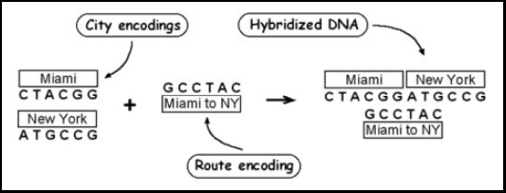
Figure 4: Route encoding between Miami and NY

Thus when the DNA strands are mixed in the test tube, the strands are hybridized to form all possible routes between the cities. Figure 5 shows some of the possible routes.

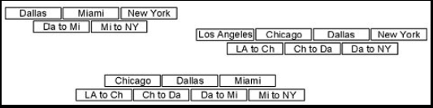
Figure 5: Sample possible routes between cities

Our test tube now consists of DNA strands of various length with all possible routes among the five cities. But we are only interested in the routes that start with LA and end with NY. To get only the required strands, we use a technique called Polymerase Chain Reaction (PCR). PCR is an iterative process used to amplify a piece of DNA across several orders of magnitude creating several copies of a particular DNA sequence. The main enzyme that helps in the amplification process is polymerase, hence the name Polymerase Chain Reaction. Essentially polymerase copies a section of a single stranded DNA starting at the position of a primer to one end of the section of the DNA we are interested in. So in order to amplify the itineraries that start with LA and end with NY, we use primers that are compliment to LA and NY. After the end of PCR process, we are left with a test tube full of DNA strands with encoded itineraries that start with LA and end with NY. But the number of cities visited between LA and NY may vary.
Next step is to separate the DNA strands such that we only have the ones that are five cities long. To accomplish this task we use a technique called Gel Electrophoresis, which is a common procedure used to separate molecules based on their size. In this technique, DNA is passed through a gel matrix by using an electric field. The gel in the gel matrix is a cross linked polymer that forms a meshwork of linked strands. DNA molecules are generally negatively charged, so when placed in an electric field they are attracted towards the positive terminal. Since the DNA strands should travel through the gel matrix, the rate at which the strands can travel highly depends on the length of the strand. That is, DNA strands of shorter length travel quickly when compared to strands of more length as shown in Figure 6. Typically we end up with different DNA bands where each band corresponds to a particular length DNA.

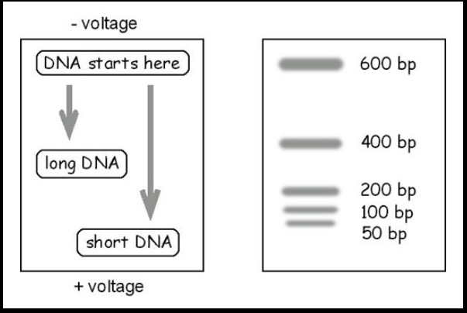
Figure 6: Effect of Gel matrix on DNA strands
Now we have the DNA strands whose encodings correspond to the itineraries that start with LA and end with NY and the number of cities in the itinerary is five. Next, final step is to filter out the DNA strands that contain all the cities. This can be accomplished by a technique called Affinity chromatography, which is a method used to separate mixtures based on interaction between enzymes and substrate. Since this technique is mainly used to purify a mixture, it is often known as Affinity Purification. In this step we attach a compliment of the encoded sequence of required city to a substrate such as a magnetic bead and mixed with the DNA. The sequence attached to the bead hybridizes with its compliment sequence in the DNA mixture. By doing this process for all the five cities, we are left with the DNA strand whose encoding is the itinerary from LA to NY, visiting each of the cities once in between.

SAT Problem
The Satisfiability Problem (SAT) can be solved using the enzymatic ligation reactions of DNA ‘words’ on surfaces [7]. A DNA word is a single DNA strand of 16-base oligonucleotides (16mers). The enzyme ligase is used to join the DNA words on a chemically modified thin gold film. The structure of DNA word [6] is as shown in Figure 7.

Figure 7: DNA word

Each word contain 8 fixed word label bases (represented by ‘F’) and 8 variable bases (represented by ‘v’). The word label sequence is the same (“Fixed”) for every 16mer in a word set; additional word sets are generated by varying the word label sequence. By linking different word sets together to form DNA word strands, large combinatorial mixtures can be created. For example, a set of 256 distinct 16mers contains 2⁸ words and is defined as an 8 bit word set. Linking four words together from four different 8 bit word sets would produce a combinatorial set of 4.3 * 10⁹ unique 64mers.

In this section we first see the overview of DNA computing on surfaces (Figure 8) and then apply this technique to solve the SAT problem. Initially, a combinatorial set of DNA molecules representing all possible solutions to a given problem is synthesized and immobilized on a surface via a reactive functional group X. Next, a series of ‘Mark’, ‘Destroy’ and ‘Unmark’ operations are performed to arrive at the final solution.
- Mark: In this operation, the DNA molecules immobilized to the surface are exposed to a combinatorial mixture of DNA words; those strands that find a complement on the surface are bound to form a duplex. Thus, after the Mark operation we have double-stranded molecules (“marked” strands) and single- stranded molecules (“unmarked” strands).
- Destroy: In this operation, the surface is exposed to a solution containing the enzyme E. coli Exonuclease I. This enzyme breaks/destroys all the single stranded words (‘unmarked’ words) and leaves alone the double stranded words. This process is known as ‘enzymatic digestion’.
- Unmark: In Unmark, as the name suggests the marked words are unmarked by exposing the surface to a solution of 8.3 M urea at 37 °C.

Figure 8: Overview of DNA Computing on surfaces

Now, let us consider a SAT problem and see how it can be solved using DNA computing. A simple example of SAT problem is:

(x or z) and (not y)

This above example consists of two sub-expressions ((x or z), (not y)) separated by the Boolean operation ‘And’ over three variables x, y and z. The SAT problem here is to determine if there exits an assignment of true/false values to the variables x, y, and z that satisfy the equation. To determine the satisfiability, every possible truth assignment (e.g., TTT, TFF, etc.) of the variables (as shown in table 2) is represented as a unique DNA word.

Table 2. Truth assignments of variables
X | Y | Z
F | F | F
F | F | T
F | T | F
F | T | T
T | F | F
T | F | T
T | T | F
T | T | T

Since there are three variables and each variable can be either true or false, we have 2³ = 8 truth assignment combinations. A combinatorial set of these 8 words is synthesized and immobilized on to the surface. A series of Mark, Destroy and Unmark operations is performed twice, once for each sub-expression. Every cycle of Mark, Destroy and Unmark operations removes from the surface the strands that do not satisfy the sub-expression under consideration. So in the first cycle, considering the sub-expression (x or z) the Mark operation will mark all the strands in which x is set to ‘T’ or z is set to ‘T’. As a result, out of the 8 strands 6 strands are marked and the two strands (FFF and FTF) in which neither x nor z is ‘T’ remain unmarked. The Destroy operation removes the two unmarked strands from the surface and the Unmark operation the remaining six strands are unmarked into single strands. This process is repeated for the second sub-expression. At the end of two cycles, only those strands which simultaneously satisfy both the sub-expressions remain on the surface. The sequence(s) of these surface-bound DNA words is then ascertained in a Readout operation by either conventional electrophoresis-based DNA sequencing or hybridization to DNA arrays. In general, for problems containing N clauses, the cycle Mark, Destroy, Unmark is repeated N times.

Advantages

DNA computers have the potential to take computing to new levels, picking up where Moore's Law leaves off. Some of the advantages DNA computers have over silicon computers are:
- Since almost all the living organisms on Earth contain DNA, there will be a continuous supply of DNA.
- The large supply of DNA makes it an inexpensive resource.
- Manufacture of DNA chips does not produce any harmful byproducts, unlike the traditional silicon chips.
- DNA computers are orders of magnitude smaller and light weight compared to silicon based computers.
- Power consumption of DNA computers is very less, since power is only needed to keep the DNA molecules from denaturing.
The key advantage of DNA computers comes from the fact that they are way smaller than the conventional computers and yet store large amounts of data. It is not an exaggeration to say that one pound of DNA has the capacity to store more information than all the electronic computers ever built; and the computing power of a teardrop-sized DNA computer, using the DNA logic gates, will be more powerful than the world's most powerful supercomputer. 1 cubic centimeter (0.06 cubic inches) of area can hold more than 10 trillion DNA molecules. With this small amount of DNA, a computer would be able to store 10 terabytes of data, and perform 10 trillion calculations in parallel. By adding more DNA, more calculations could be performed [4]. The data density in a DNA computer is around million Gbits/inch whereas the data density in a typical high performance HDD is around 7 Gbits/inch.
One more important feature of DNA computers is parallel processing. Unlike conventional computers which operate linearly, performing one task at a time, DNA computers perform calculations in parallel. A test tube of DNA can contain trillions of strands and each operation on the test tube is carried out by all the strands in parallel i.e., we can essentially carry out trillions of operations in parallel. The ability of parallel computing allows DNA computers to solve complex mathematical problems in hours, whereas it might take conventional computers hundreds of years to complete.

Limitations

Though DNA computing seems to produce promising results so far in the experiments conducted, there are some serious limitations in this field.
- The primary limitation in DNA computing is, it takes much longer time to sort out the results and get the correct answer than it took to solve the problem.
- Requires human assistance and lab procedures.
- Cannot run application software.
- DNA tends to decay, hence should take proper measures to keep it from decaying.

Conclusion

Current research in DNA computing has already proven that DNA computers are capable of solving complex mathematical equations and storing enormous amounts of data. Though DNA Computing is still in its infancy stage, further research in the field might rise curtains to a new age of computing. However, the field of DNA computing is not about competing and/or replacing traditional silicon based computers than about finding new combinations of biology and computer science. The first DNA computers may not support any fancy applications but could be used by government agencies for cracking secret codes, aviation industry for planning efficient routes, etc.

REFERENCES

- DNA Computing - http://en.wikipedia.org/wiki/DNA_computing
- Hamiltonian Path Problem - http://archive.arstechnica.com/reviews/2q00/dna/dna-1.html
- Moore’s Law - http://en.wikipedia.org/wiki/Moore%27s_law
- DNA Computing - http://computer.howstuffworks.com/dna-computer.htm
- Adleman, L.M., Molecular computation of solutions to combinatorial problems, Science, 226 (1994), 1021-1024

- DNA Word design strategy - http://corninfo.ps.uci.edu/reprints/RMC55.pdf
- DNA Computing on surfaces - http://corninfo.ps.uci.edu/reprints/RMC60.pdf
- http://www.economist.com/node/21548488
- http://www.dna.caltech.edu/DNAresearch_publications.html
- http://apcmag.com/intel-looks-beyond-silicon-for-processors-past-2017.htm

